**Assignment No: 01 & 02**

**Aim:** Install Google App Engine. Create hello world app and other simple web applications using python/java.

**Theory:**

**Introduction of Google App Engine :**

Google App Engine lets you run your web applications on Google's infrastructure. App Engine applications are easy to build, easy to maintain, and easy to scale as your traffic and data storage needs grow. With App Engine, there are no servers to maintain: You just upload your application, and it's ready to serve your users.

You can serve your app from your own domain name (such as https:/[/www.example.com/)](http://www.example.com/)) using Google Apps. Or, you can serve your app using a free name on the appspot.com domain. You can share your application with the world, or limit access to members of your organization.

Google App Engine supports apps written in several programming languages. With App Engine's Java runtime environment, you can build your app using standard Java technologies, including the JVM, Java servlets, and the Java programming language—or any other language using a JVM-based interpreter or compiler, such as JavaScript or Ruby. App Engine also features a dedicated Python runtime environment, which includes a fast Python interpreter and the Python standard library. The Java and Python runtime environments are built to ensure that your application runs quickly, securely, and without interference from other apps on the system.

With App Engine, you only pay for what you use. There are no set-up costs and no recurring fees. The resources your application uses, such as storage and bandwidth, are measured by the gigabyte, and billed at competitive rates. You control the maximum amounts of resources your app can consume, so it always stays within your budget. App Engine costs nothing to get started. All applications can use up to 500 MB of storage and enough CPU and bandwidth to support an efficient app serving around 5 million page views a month, absolutely free. When you enable billing for your application, your free limits are raised, and you only pay for resources you use above the free levels.

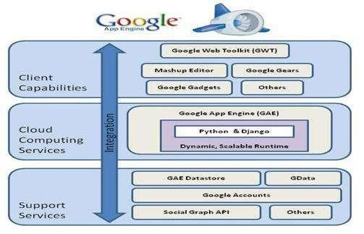**Architecture of Google App Engine:**

**Features of Google App Engine:**

* **Language support:**

Google App Engine lets users’ environment to build applications in some of the most popular languages, including Java, Python, Ruby, Golang, Node.js, C#, and PHP.

* **Flexibility:**

Google App Engine offers the flexibility to import libraries & frameworks through Docker containers.

* **Diagnostics:**

Google App Engine uses cloud monitoring and logging to monitor health and performance of an application which helps to diagnose and fix bugs quickly. The error reporting document helps developers fix bugs on an immediate basis.

* **Traffic splitting:**

Google App Engine automatically routes the incoming traffic to different application versions as a part of A/B testing. This enables users to easily create environments for developing, staging, production and testing.

* **Security:**

Google App Engine enables users to define access rules in Engine’s firewall and utilize SSL/TLS certificates on custom domains for free.

**Result:** Thus the Google App Engine is installed successfully and a web application to display hello world using java.

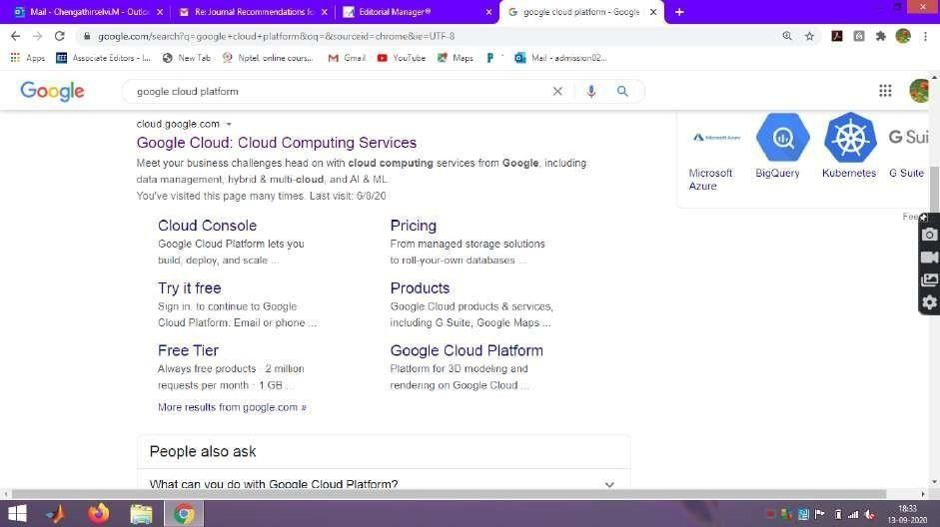**Step1 : Login to** [**www.cloud.google.com**](http://www.cloud.google.com/)

**Step2 : Goto Console**

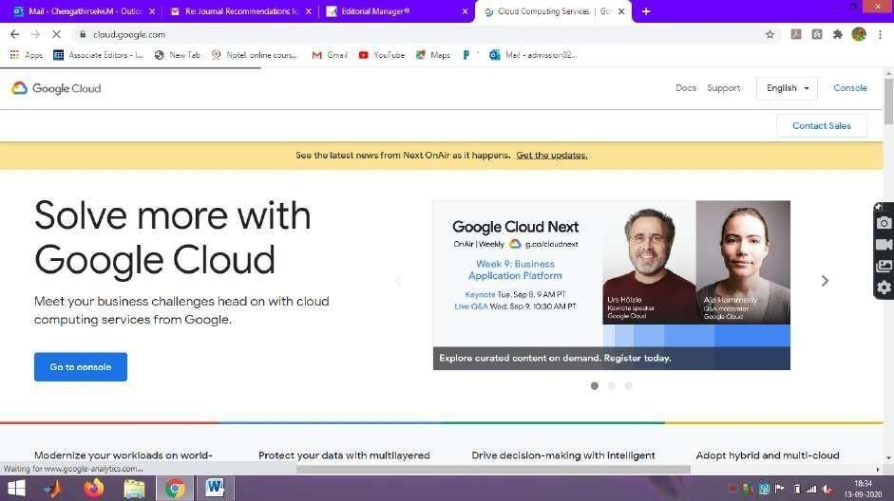

**Step 3 : Google Cloud Platform is shown**

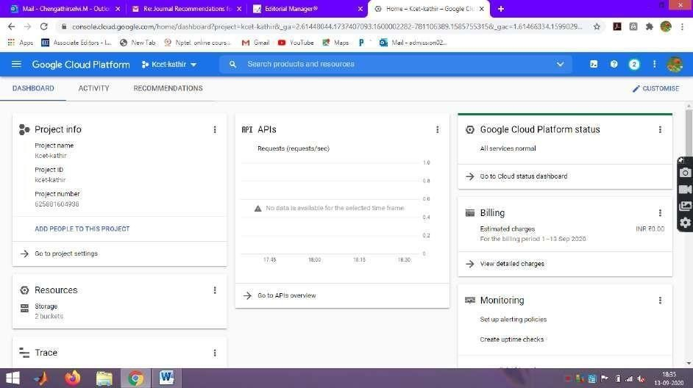

**Step 4 : Click Dashboard in the Google Cloud Plaform**

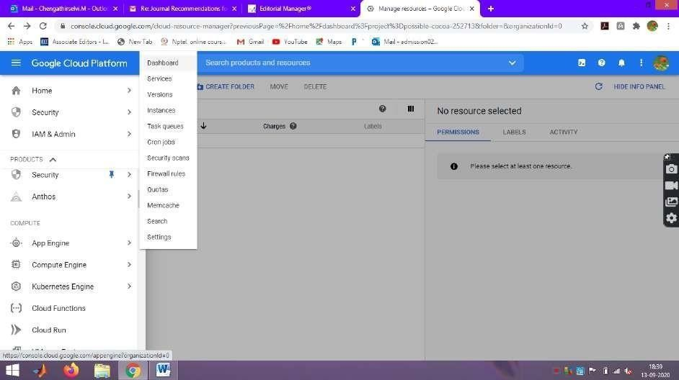**Step 5 : Dashboard in the Google Cloud Plaform**

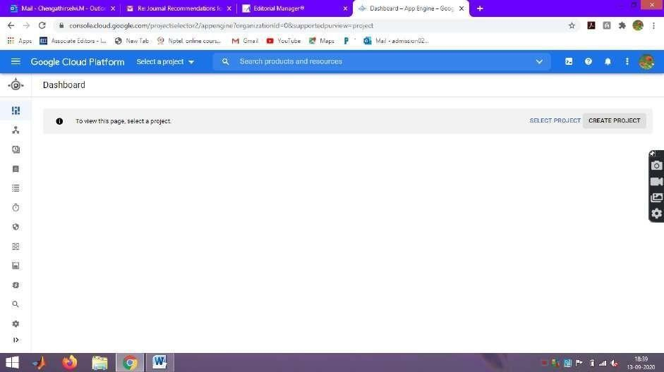

**Step 6 : Click New Project and give unique Project Name.**

Example : kcet-cloud-project

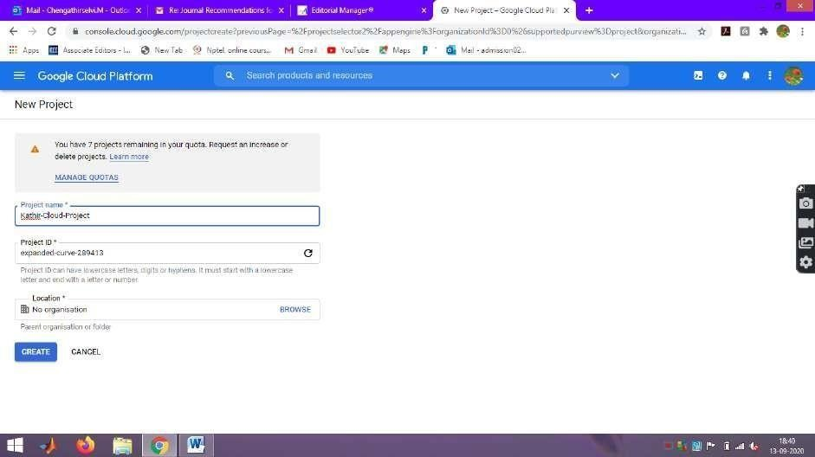

**Step 7 : Google App Engine is initiated**

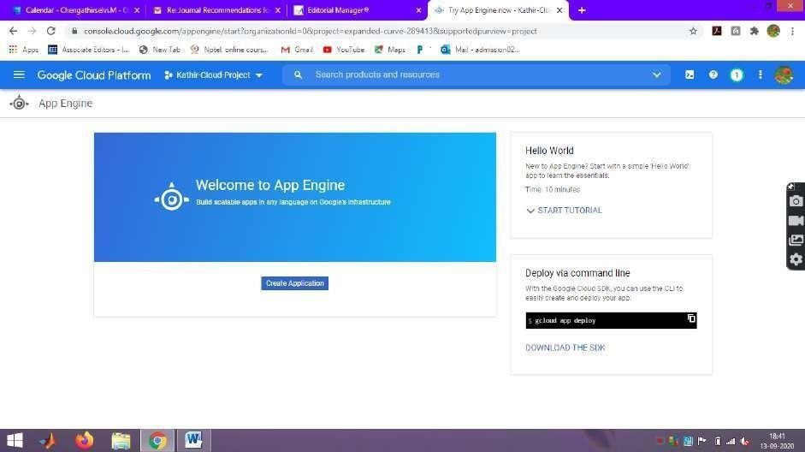

**Step 8 : Click create Application**

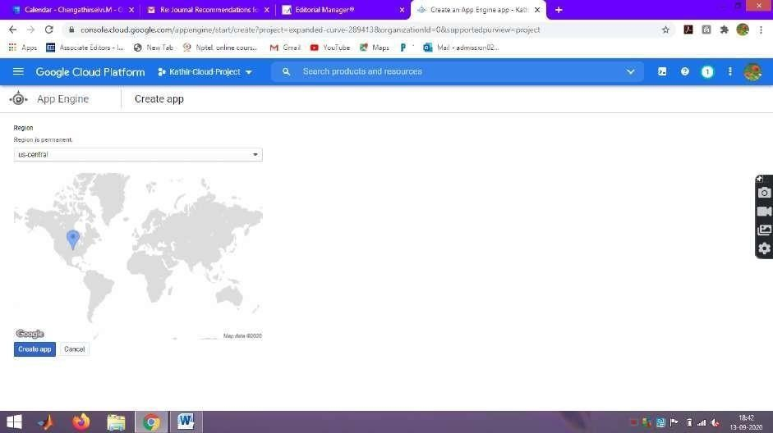

**Step 9 : Create app and Select Language Python**

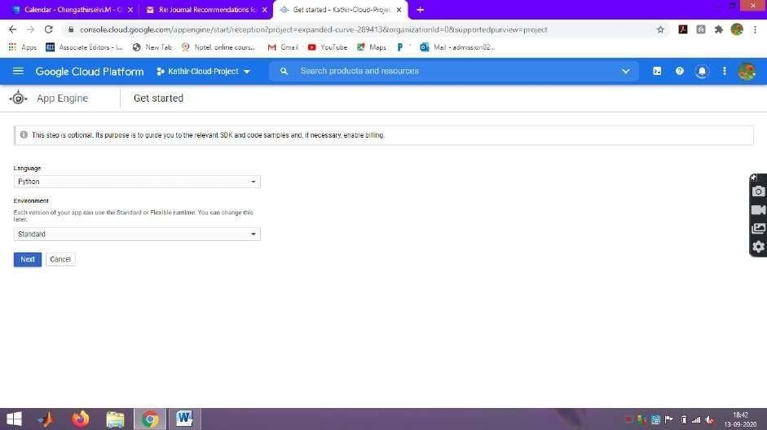

**Step 10 : Python app is created in Google App Engine**

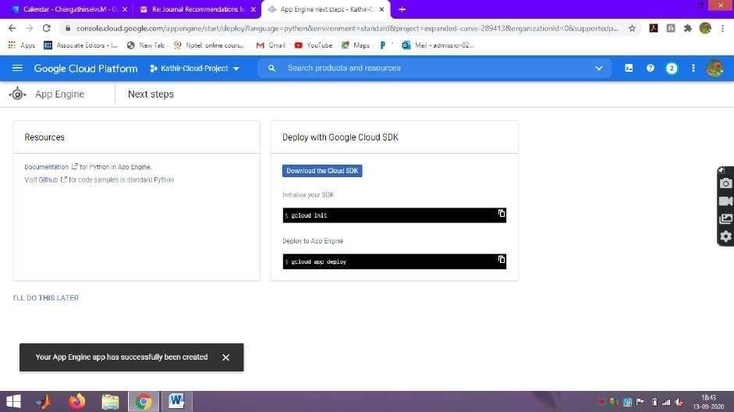

**Step 11 : Python app Engine application is created**

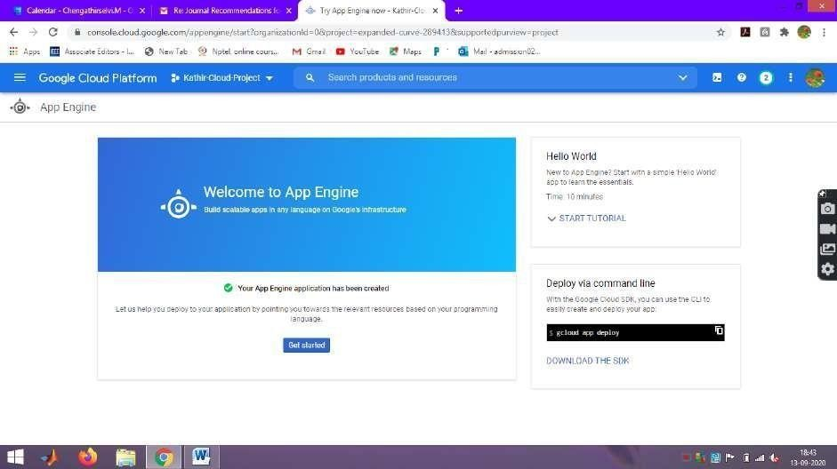

**Step 12 : Click Cloud Shell in the Kathir-Cloud-Project**

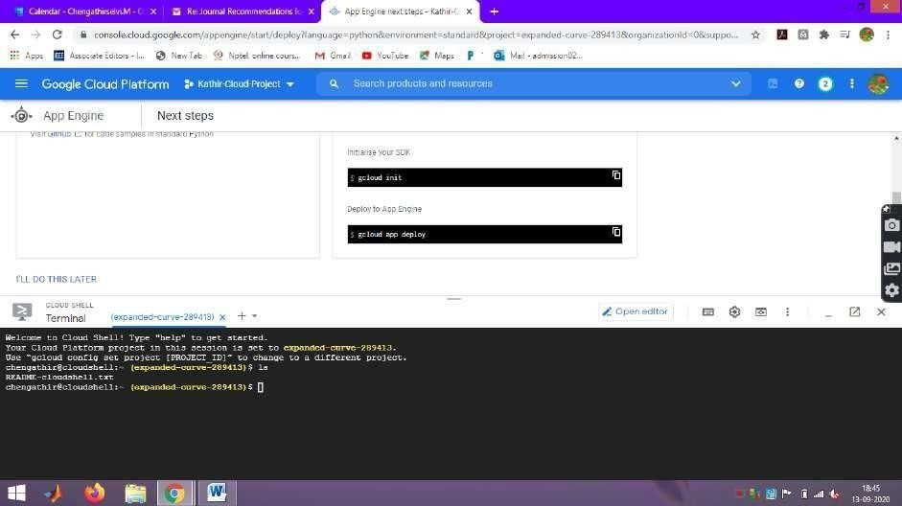

**Step 13 : Create a Directory PythonProject using mkdir command**

Syntax : mkdir PythonProject

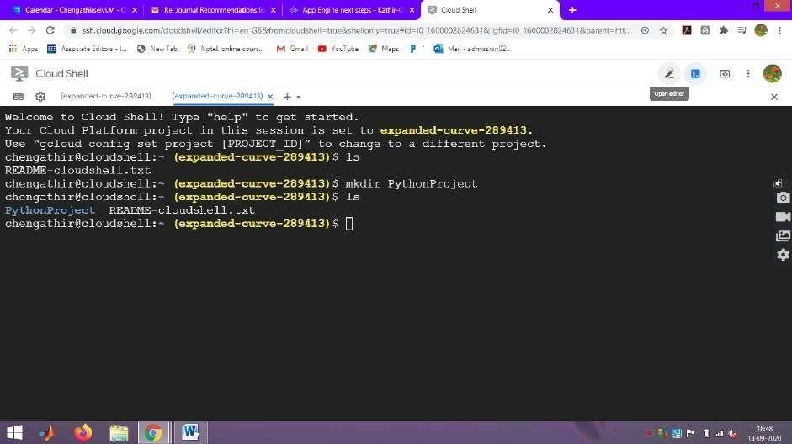

**Step 14 : Click Editor to create Python application**

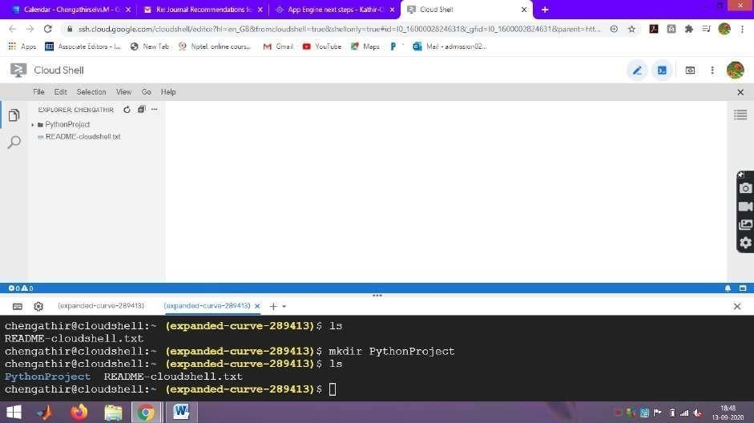

**Step 15 : Click New File in the PythonProject Folder (Python file)**

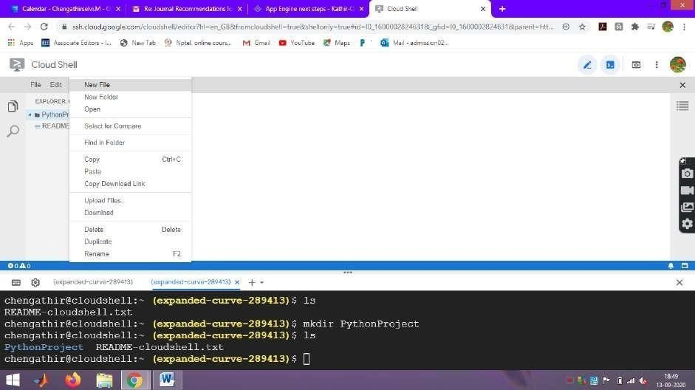

**Step 16 : Create main.py file**

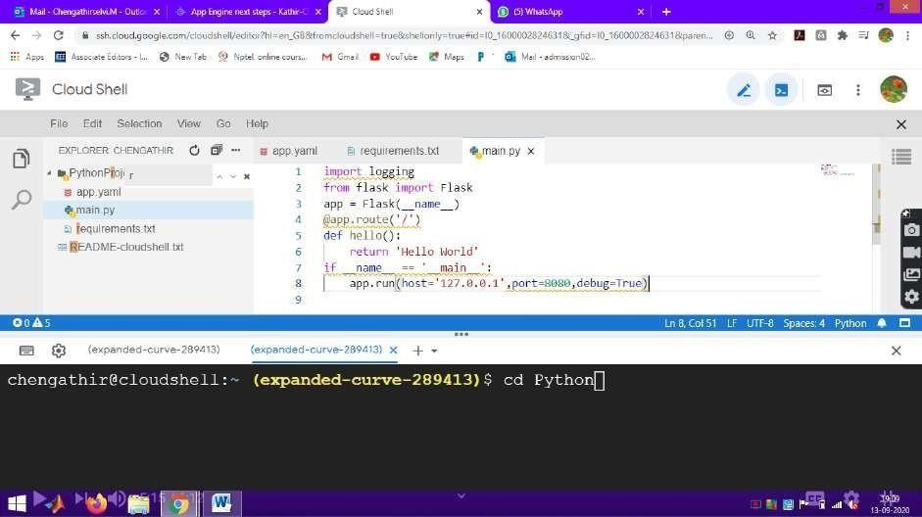

**main.py file**

import &nbsplogging

from &nbspflask import &nbspFlask app =&nbspFlask( name )

@app.route('/') def hello():

return 'Hello&nbspWorld'

if name == ' main ': &nbspapp.run(host='127.0.0.1',port=8080, debug=True)

**Step 17 : Create app.yaml file**

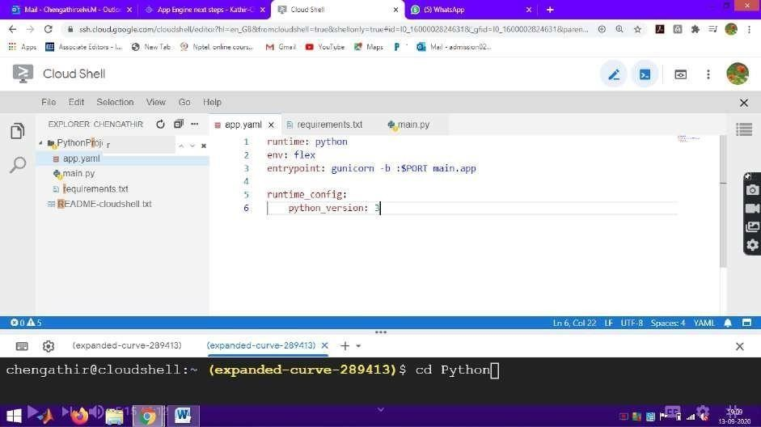

**app.yaml**

runtime: python env: flex

entrypoint: gunicorn -b :$PORT&nbspmain:app

runtime_config: python_version: 3

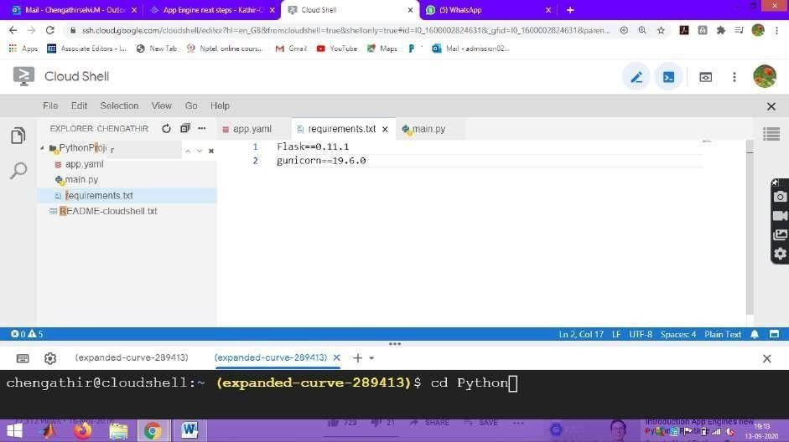**Step 18 : Create requirements.txt file**

**requirements.txt**

Flask==0.11.1 gunicorn==19.6.0

**Step 19 : Move to Cloud Shell Environment to run the application**

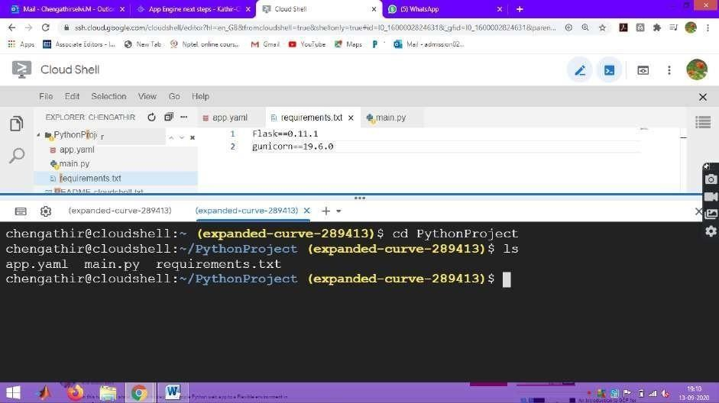

**Step 20 : Move to Cloud Shell Environment to run the application Syntax : gcloud app deploy**

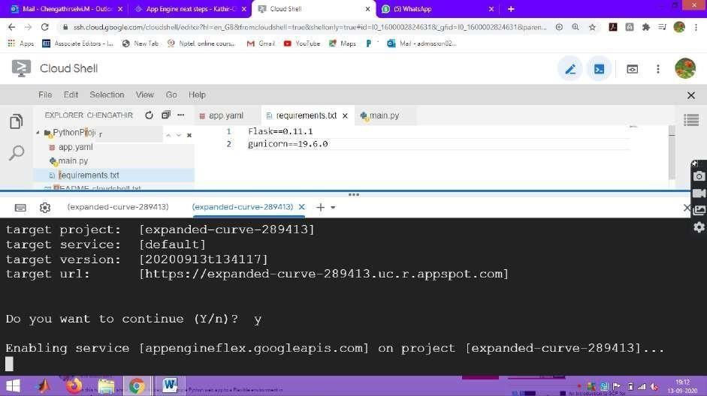

Continue the application. It enable service on the given project

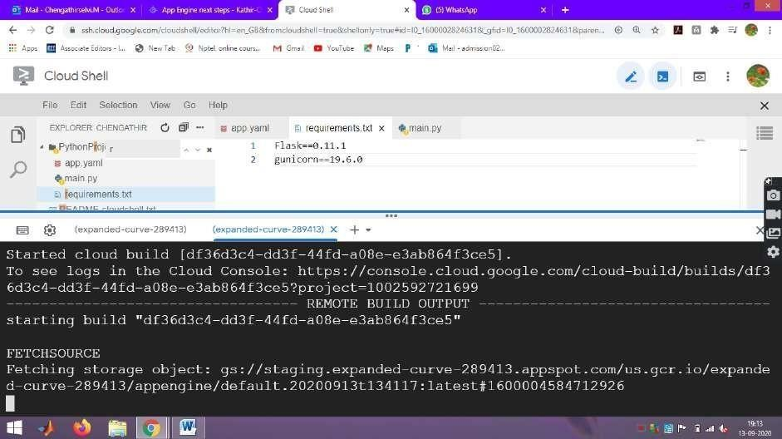

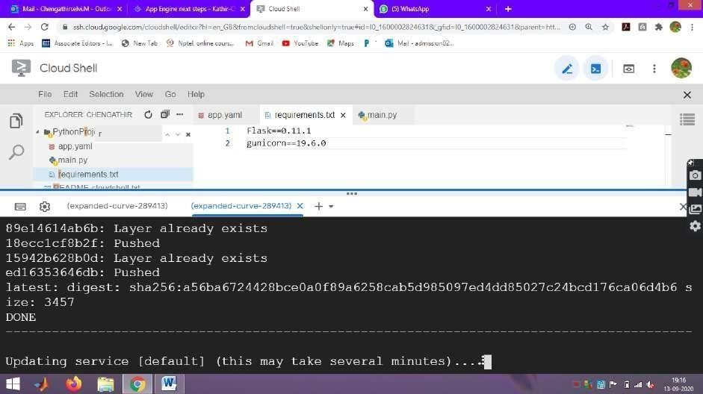It started building the object and fetching the storage object for the created application

It is updating the service

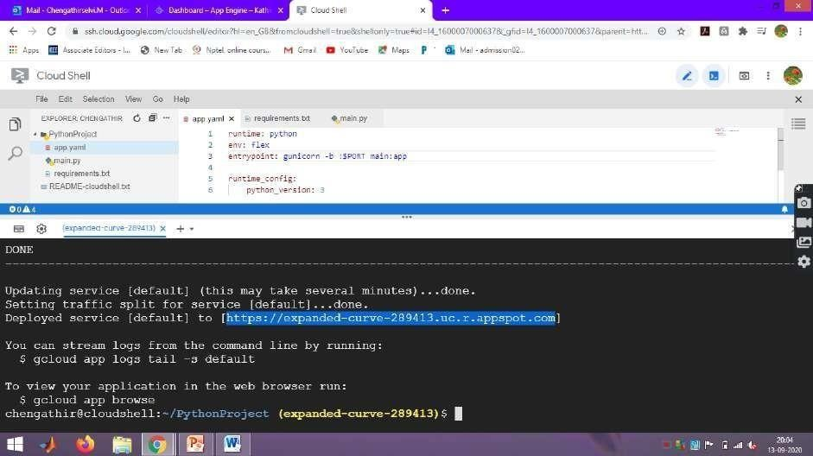

The application is successfully deployed and URL is [https://expanded-curve-289413.uc.r.appspot.com](https://expanded-curve-289413.uc.r.appspot.com/)

**Step 21 : Run your program in the broswer**

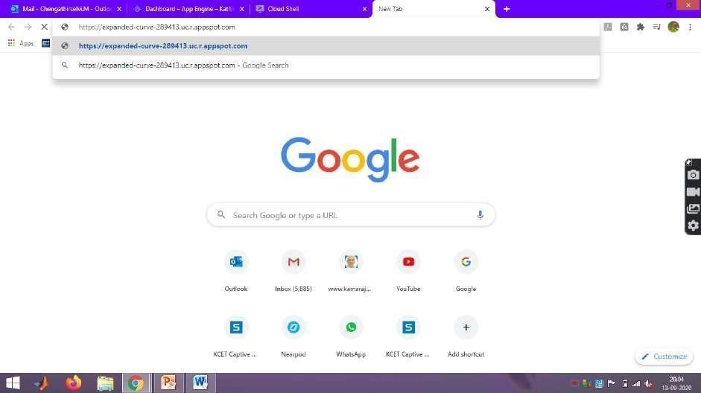

**Step 22 : Hello World Program is sucessfully run in the browser**

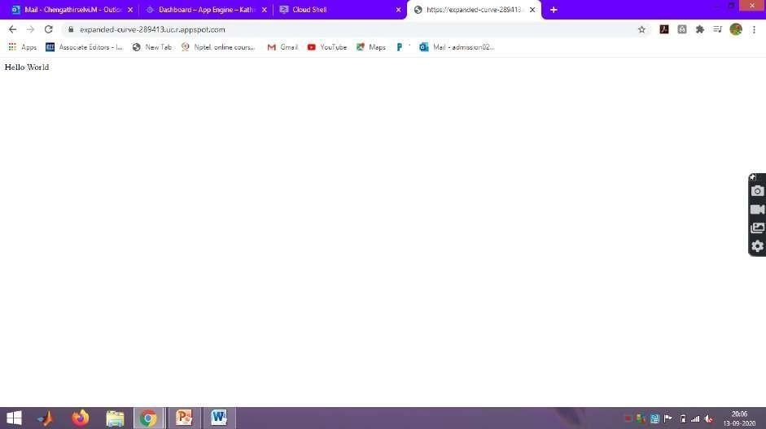

**Result:**

Thus the Google App Engine is installed successfully and a web application to display hello world using python is developed and deployed in the GAE and used GAE Launcher to launch the web applications.

**FAQ:**

1) What are the unique features of Google App Engine?

2) What are the main components of Google App Engine?

**Assignment No : 3**

**Aim:**

Simulate a cloud scenario using CloudSim and run a scheduling algorithm that is not present in CloudSim.

**Theory:**

**Introduction:**

**CloudSim**

A Framework for modeling and simulation of Cloud Computing Infrastructures and services Originally built at the Cloud Computing Distributed Systems (CLOUDS) Laboratory It is completely written in JAVA

CloudSim is an open-source framework, which is used to simulate cloud computing infrastructure and services. It is used for modelling and simulating a cloud computing environment as a means for evaluating a hypothesis prior to software development in order to reproduce tests and results.

For example, if you were to deploy an application or a website on the cloud and wanted to test the services and load that your product can handle and also tune its performance to overcome bottlenecks before risking deployment, then such evaluations could be performed by simply coding a simulation of that environment with the help of various flexible and scalable classes provided by the CloudSim package, free of cost.

**Features of cloudsim:**

1. CloudSim provides support for simulation and modelling of:
2. Large scale virtualized Datacenters, servers and hosts.
3. Customizable policies for provisioning host to virtual machines.
4. Energy-aware computational resources.
5. Application containers and federated clouds (joining and management of multiple public clouds). Datacenter network topologies and message-passing applications.
6. Dynamic insertion of simulation entities with stop and resume of simulation.
7. User-defined allocation and provisioning policies.

**Cloudsim - Layered Architecture**

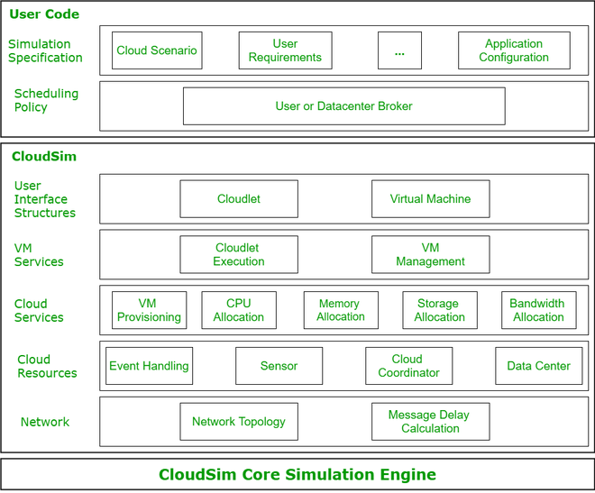

**Cloudsim - Component model classes**

* CloudInformationService.java
* Datacenter.java,Host.java,Pe.java
* Vm.java,Cloudlet.java
* DatacenterBroker.java
* Storage.java,HarddriveStorage.java, SanStorage.java

**Cloudsim - key components**

* Datacenter
* DataCenterCharacteristics
* Host
* DatacenterBroker
* RamProvisioner
* BwProvisioner
* Storage
* Vm
* VMAllocationpolicy
* VmScheduler
* Cloudlet
* CloudletScheduler
* CloudInformationService
* CloudSim
* CloudSimTags
* SimEvent
* SimEntity
* CloudsimShutdown
* FutureQueue
* DefferedQueue
* Predicate and associative classes.

**Steps for cloudsim:**

step1- download jdk version"17.0.1"

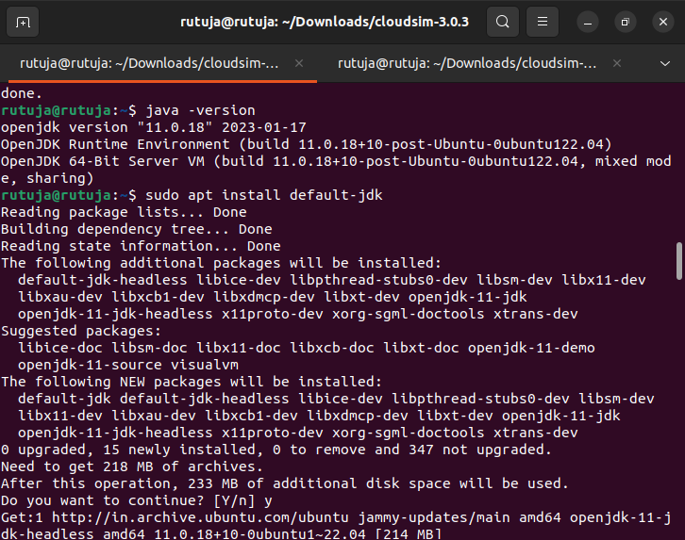

step2- open terminal

1st command: java -version

2nd command: gedit /etc/environment //to setup the environment

3rd command: sudo update-alternatives --config java

4th command: java -version //copy the path from usr upto jdk-17

5th command: ant -version

Note:(if not available then download it by running the command: sudo apt install ant)

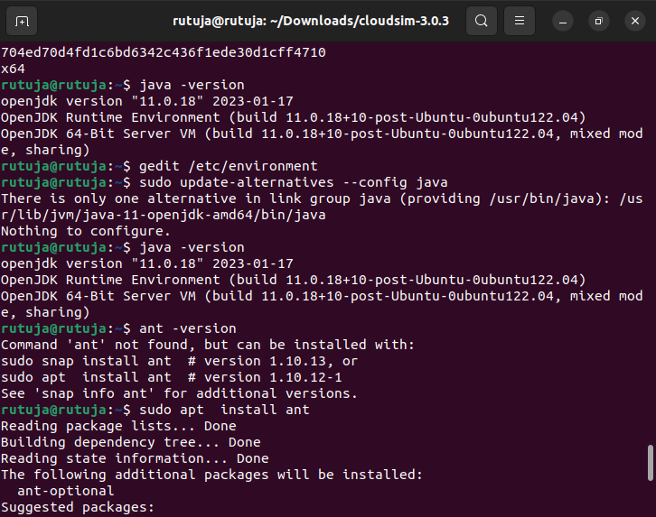

step3-

go to this github repository <https://github.com/Cloudslab/cloudsim...>

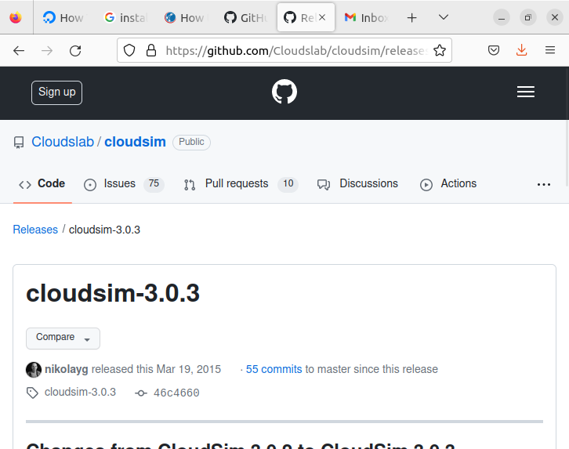

then go to cloudsim-3.0.3 download the zipfile of cloudsim

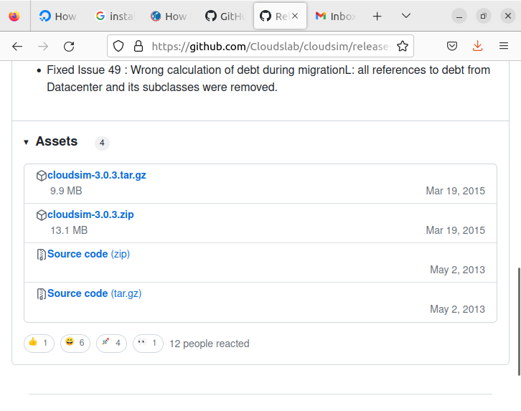

then extract the file

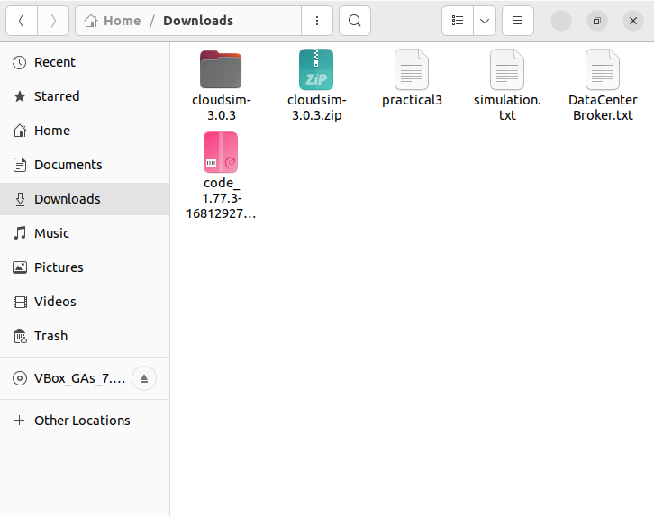

step4-go to terminal

command: cd Downloads

→ cd cloudsim-3.0.3/

→ls

Next command: : javac -classpath jars/cloudsim-3.0.3.jar:examples examples/org/cloudbus/cloudsim/examples/CloudSimExample1.java

Next command:java -classpath jars/cloudsim-3.0.3.jar:examples org.cloudbus.cloudsim.examples.CloudSimExample1

Note: if this commands run successfully means your cloudsim is install successfully.

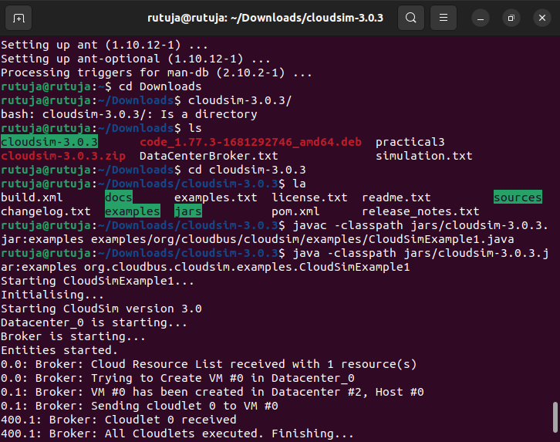

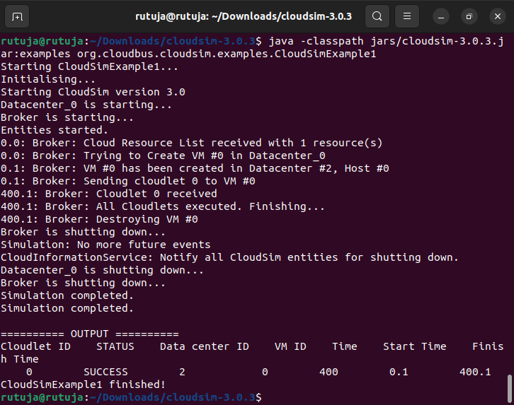

Successfully installed cloudsim.

step 5- go to vscode

upload the extracted folder of cloudsim

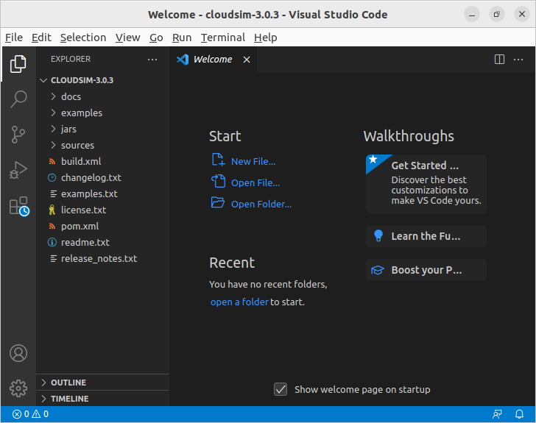

then go to sources you will get a file like DataCenterBroker.java

open this file

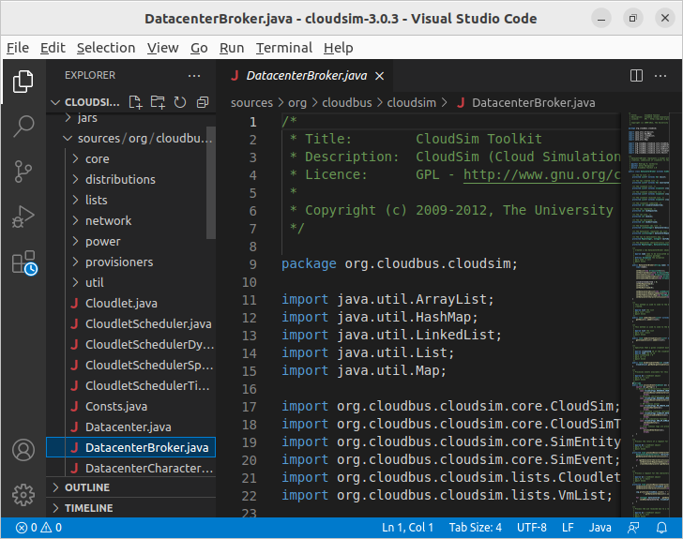

copy the code from the given file datacenter.txt

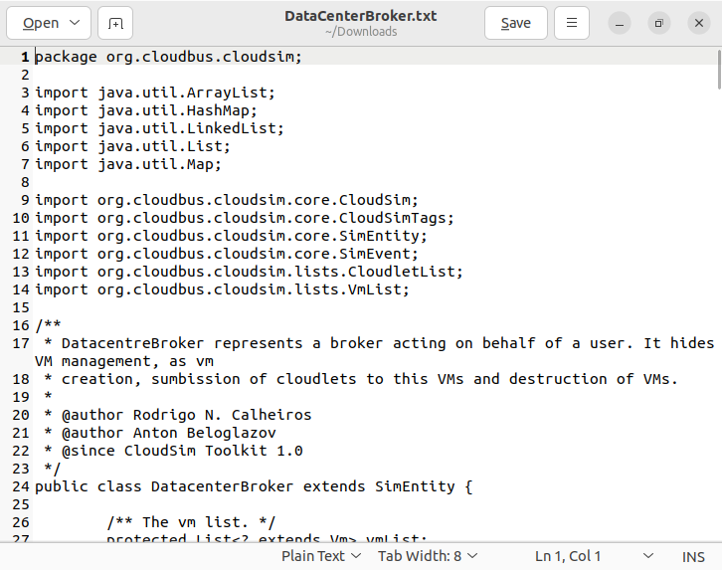

paste the above copied code from datacenter.txt to datacenter.java in vs code.

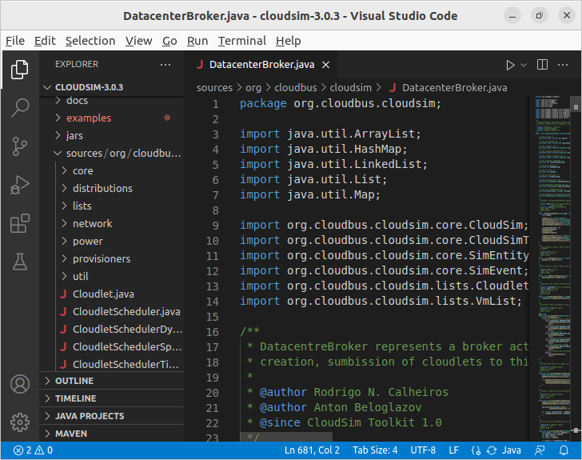

Save this file

Step 6- Now go to examples-->org-->power

In power folder create file simulation.java

Note: create file in power file only…not in planetlab and random

For creating file in power…right click on power file then create new file Simulation.java make sure that ‘S’ of simulation file should be capital

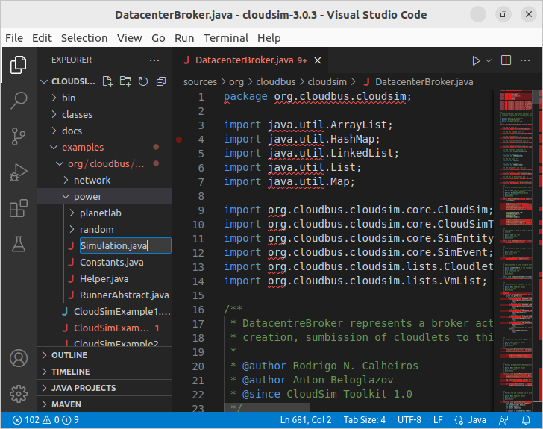

Above picture shows where to create file.

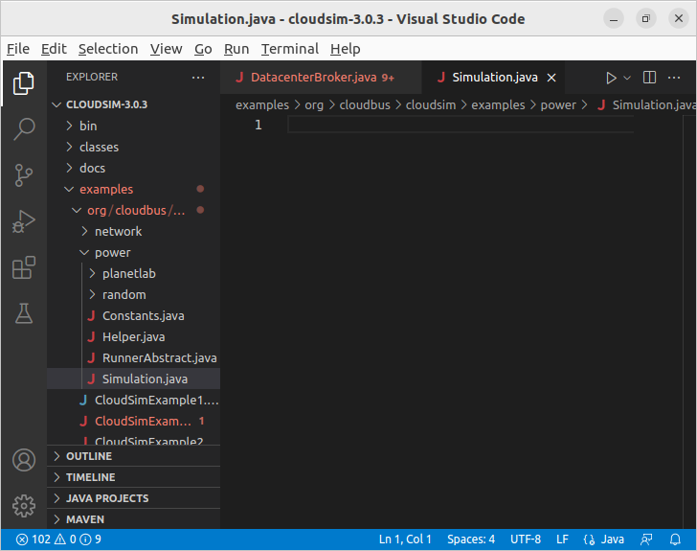

Successfully created simulation.java.

Now copy the code from simulation.txt which is provided to you

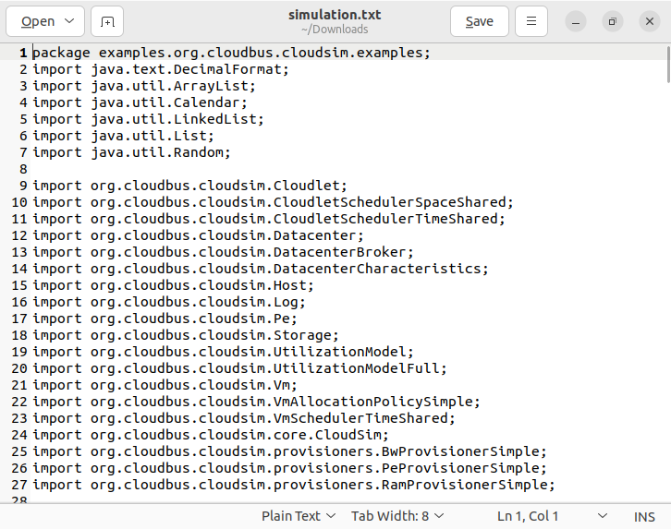

Now paste this copied code into simulation.java in vs code

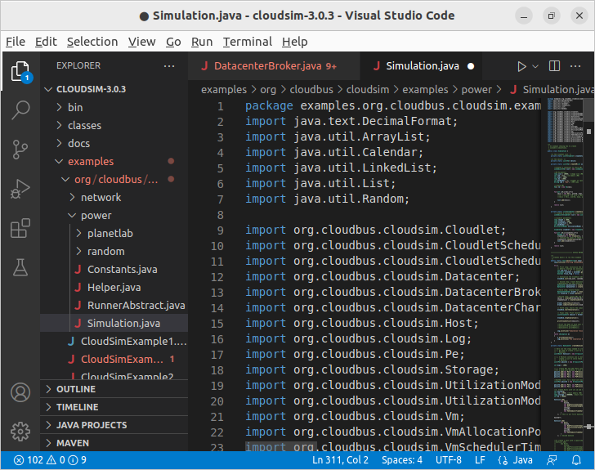

Save the file.

Step 7: go to terminal run the following command

javac -classpath jars/cloudsim-3.0.3.jar: examples/org/cloudbus/cloudsim/examples/power/Simulation.java

java -classpath jars/cloudsim-3.0.3.jar: examples/org/cloudbus/cloudsim/examples/power/Simulation.java

Before running command make sure that you must save the files which are modified in vs code

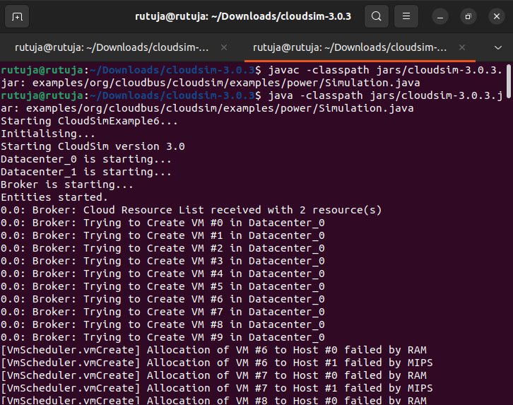

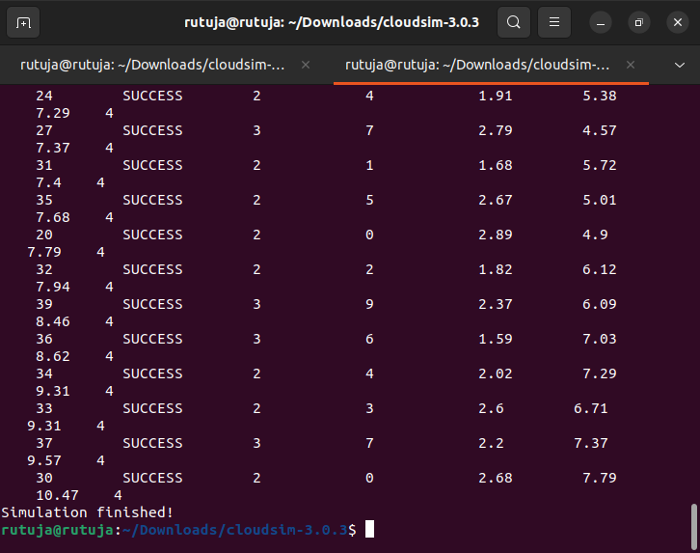

Simulation done!!!

**Result:**

Thus the scheduling algorithm is executed in cloudsim is simulated using vs code Environment successfully.

**FAQ:**

1) What is the major role of CloudSim?

2) What are the applications of CloudSim?

**Assignment No. 04**

**Aim:**

Find a procedure to transfer the files from one virtual machine to another virtual machine

**Theory:**

A virtual Machine is a logically emulated representation of a full computer system environment. Virtual machines operate based on real computer architectures, including CPU, memory, and input/output specs. The implementations for these specs may involve specific hardware, software, or a combination of both for the implementation of the full environment.

Virtual Machines can be classified based on the degree of implemented functionality for a targeted goal or device. In this way, we can say that *system virtual machines* can also be called *full Virtualization VMs*, as they are a total substitute for a real machine, complete with the ability to execute a fully functional Operating System. On the opposite end of that are *process virtual machines*, designed to execute a single application within an abstracted program execution environment, independent of platform.  
Here are a few ways virtual machines are used:

* Building and deploying apps to the cloud.
* Trying out a new operating system (OS), including beta releases.
* Spinning up a new environment to make it simpler and quicker for developers to run dev-test scenarios.
* Backing up your existing OS.
* Accessing virus-infected data or running an old application by installing an older OS.
* Running software or apps on operating systems that they weren't originally intended for

**Procedure to transfer the filesfrom one virtual machine to another virtual machine:**

**Step 1:** Install VirtualBox

1. sudo apt-get update
2. sudo apt-get install virtualbox
3. sudo apt-get install virtualbox—ext–pack

**Step2:** Download Ubuntu 18 vagrant vmdk https://drive.google.com/drive/u/0/folders/1me_nJJh0fvdDOXX3ew2jzGQpoP7f_iFt

**Step 3:** open virtualbox

Type in terminal : virtualbox

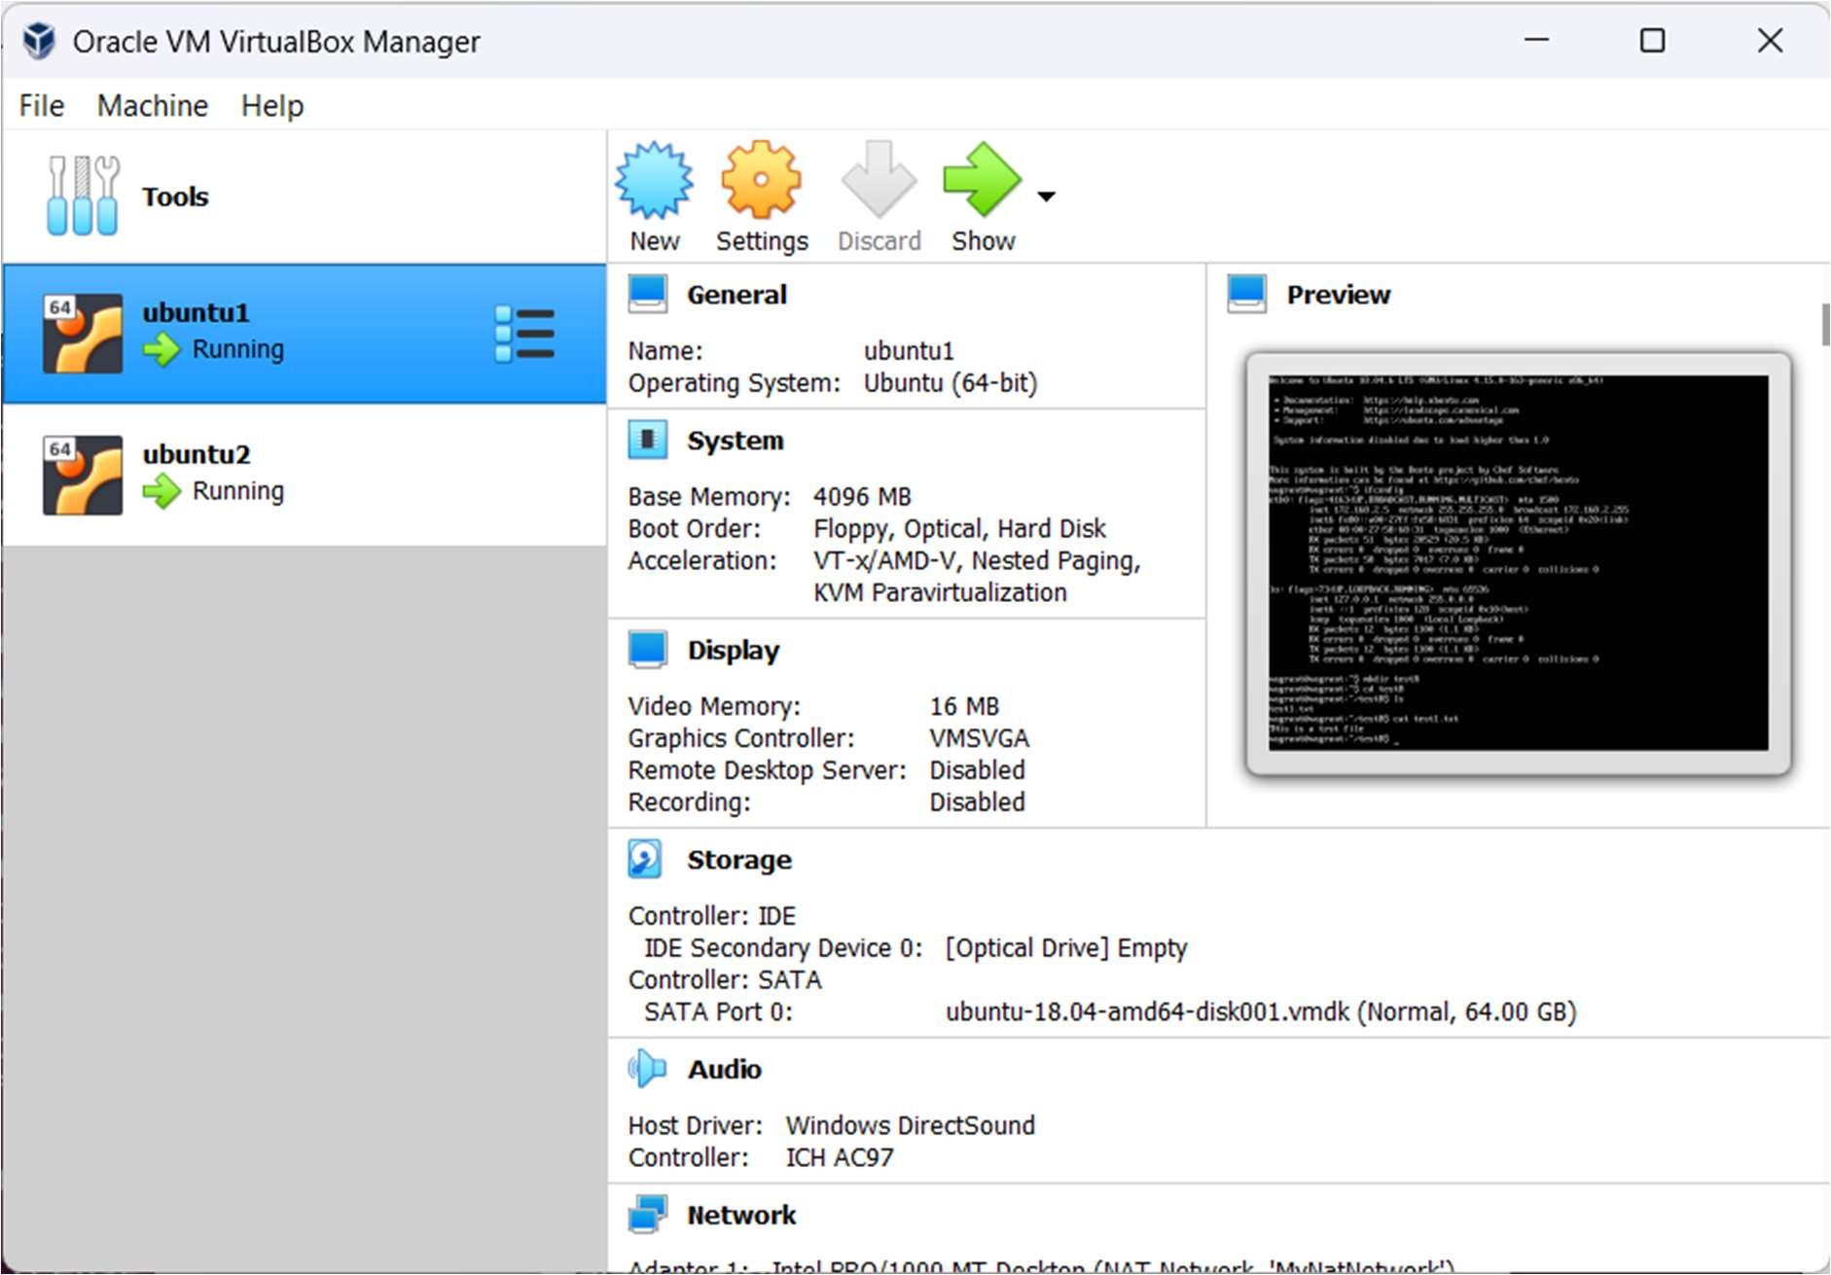

**Step 4:** Create new VM

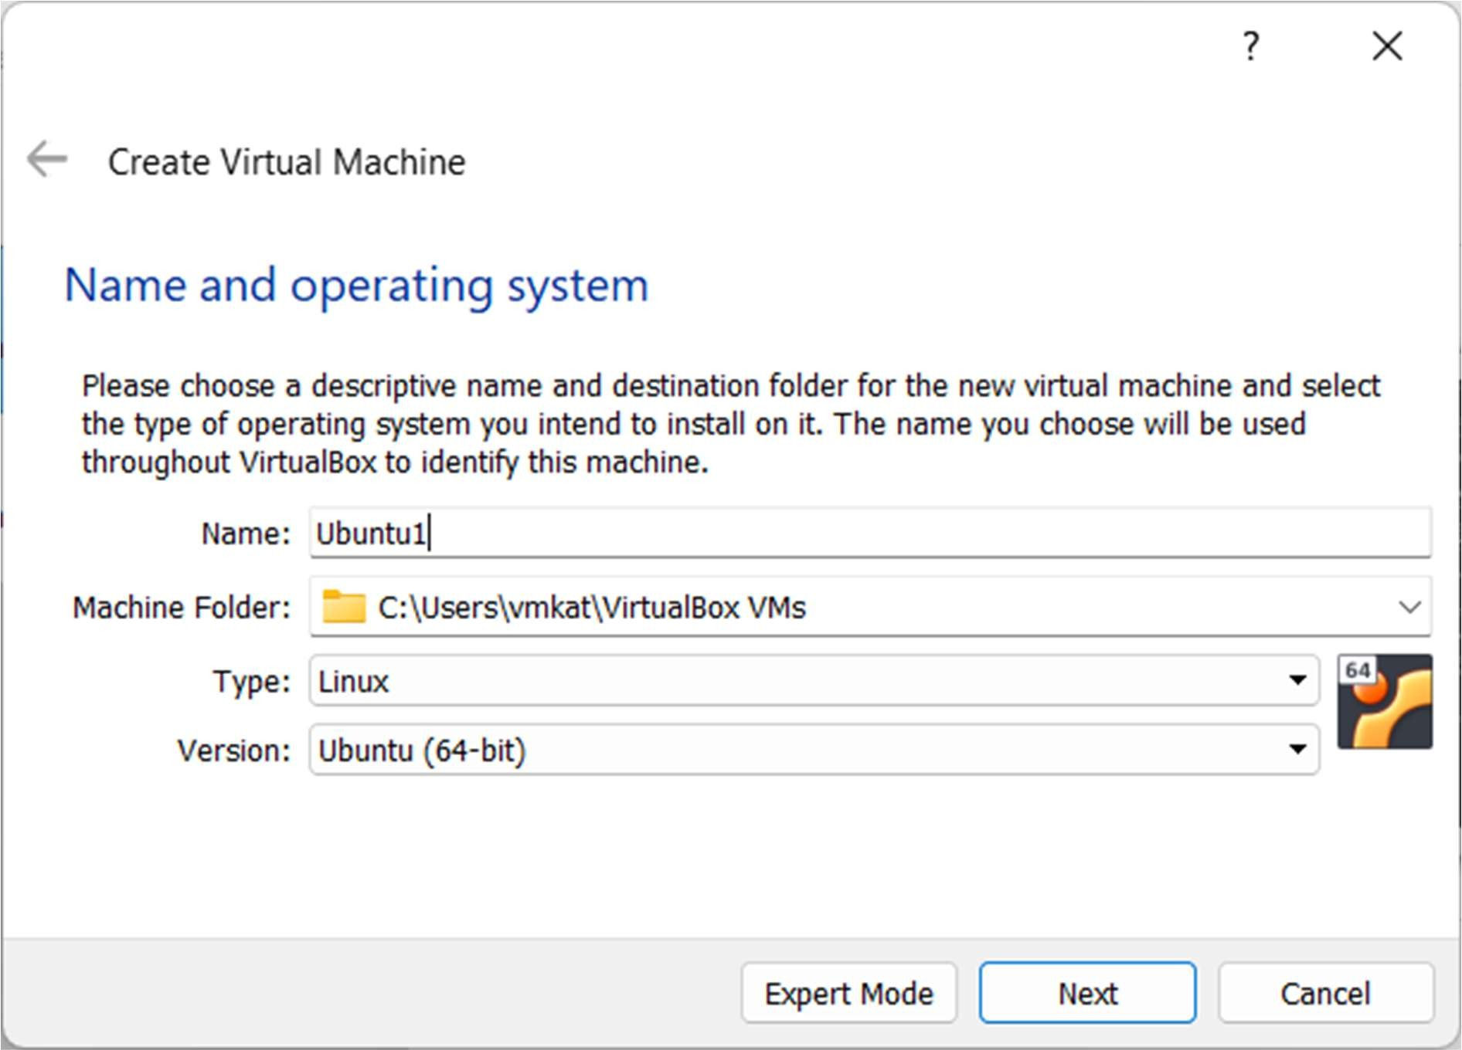 Give any name to vm

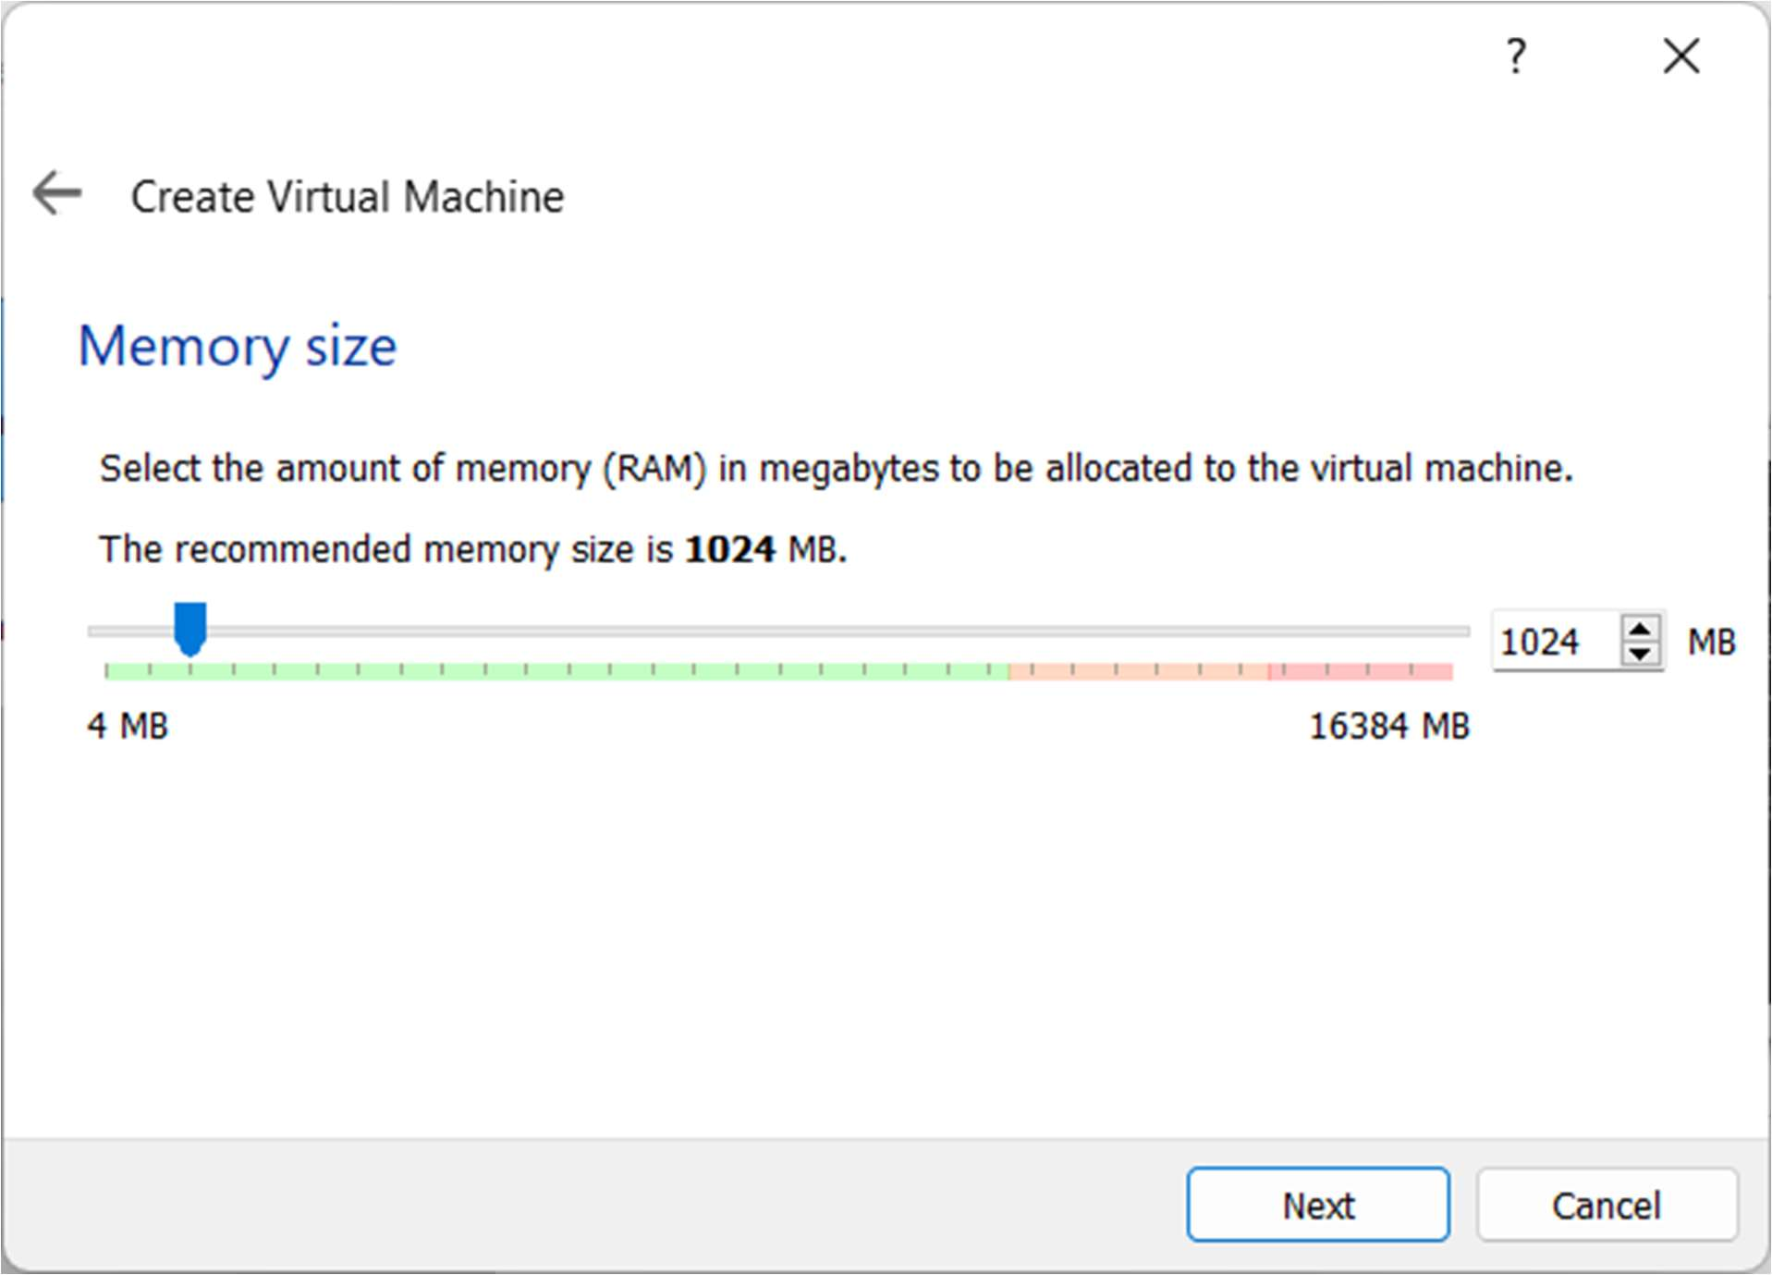

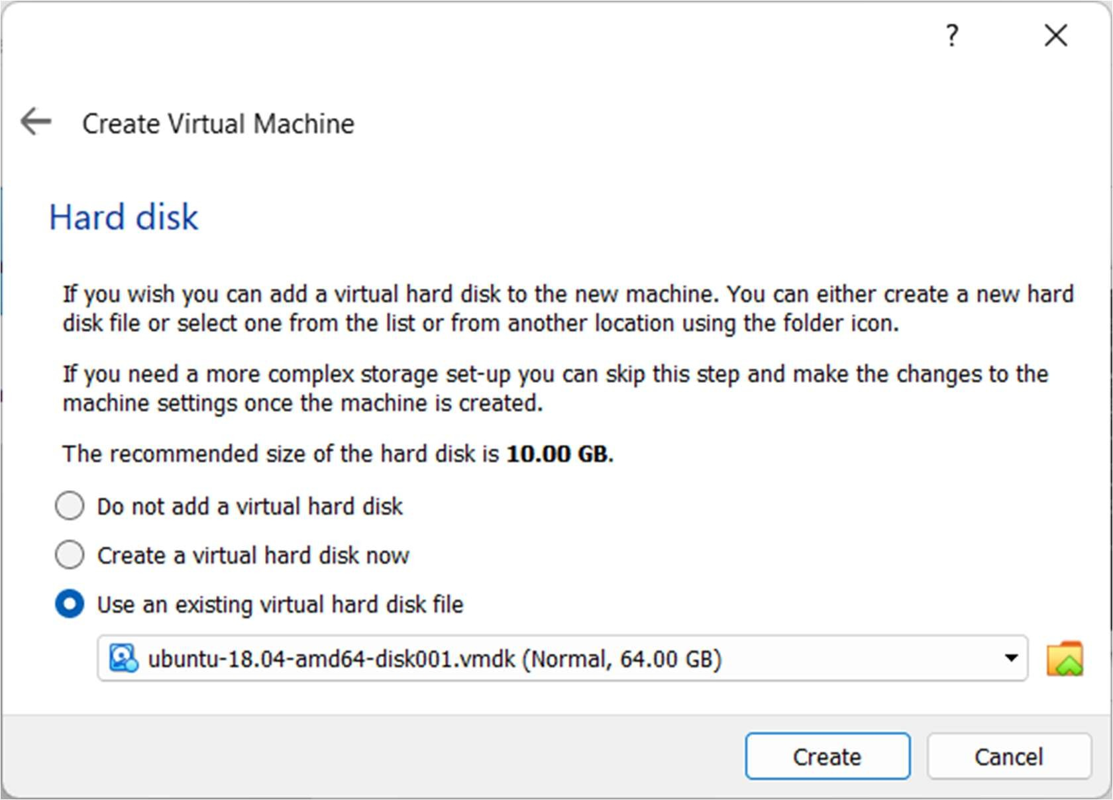

Click on Add and select ubuntu-18.04-amd64-disk001.vmdk and choose that and press Create.

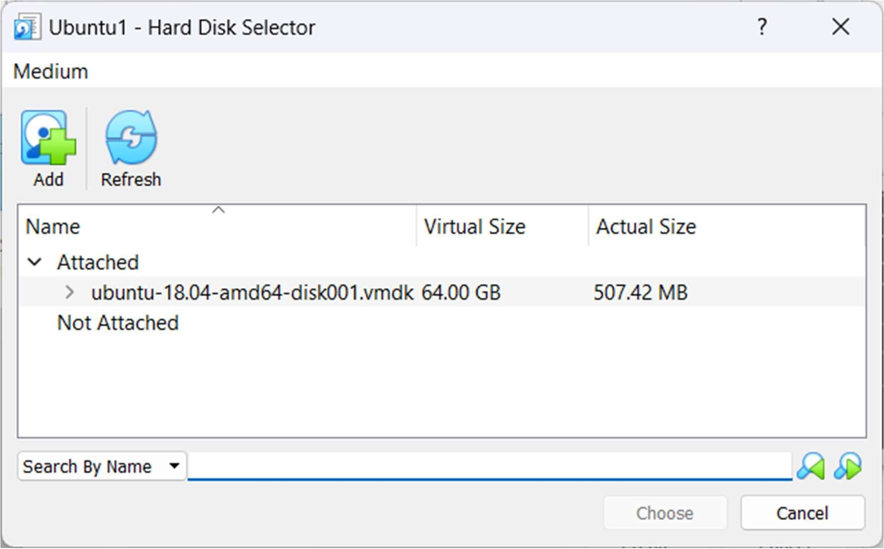

**Repeat this step and create another VM.**

**Step 4:** After create two VMs Go to Files and Preferences.

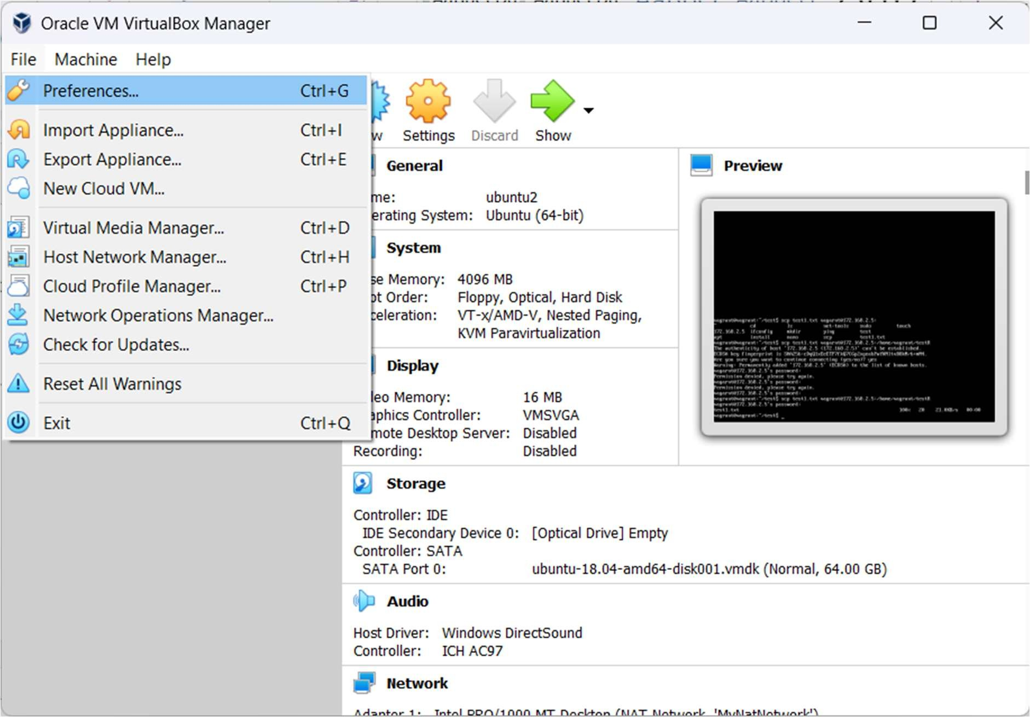

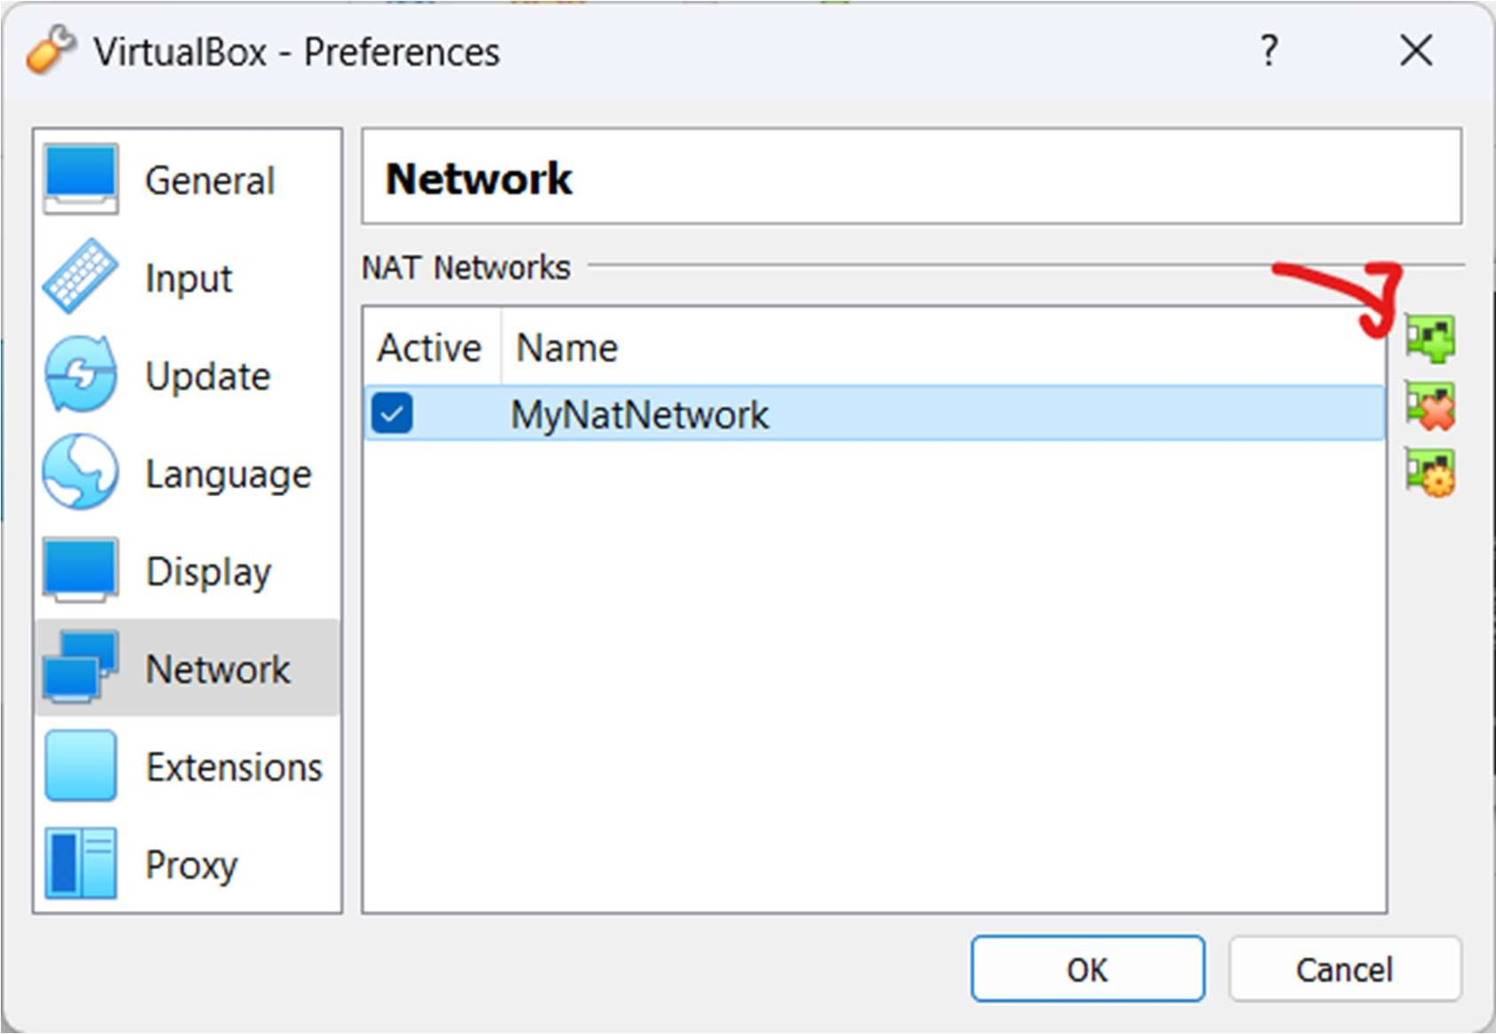Go to Network and click on following icon

After New Network is Created right click on it and edit and change Network CIDR to 172.168.2.0/24

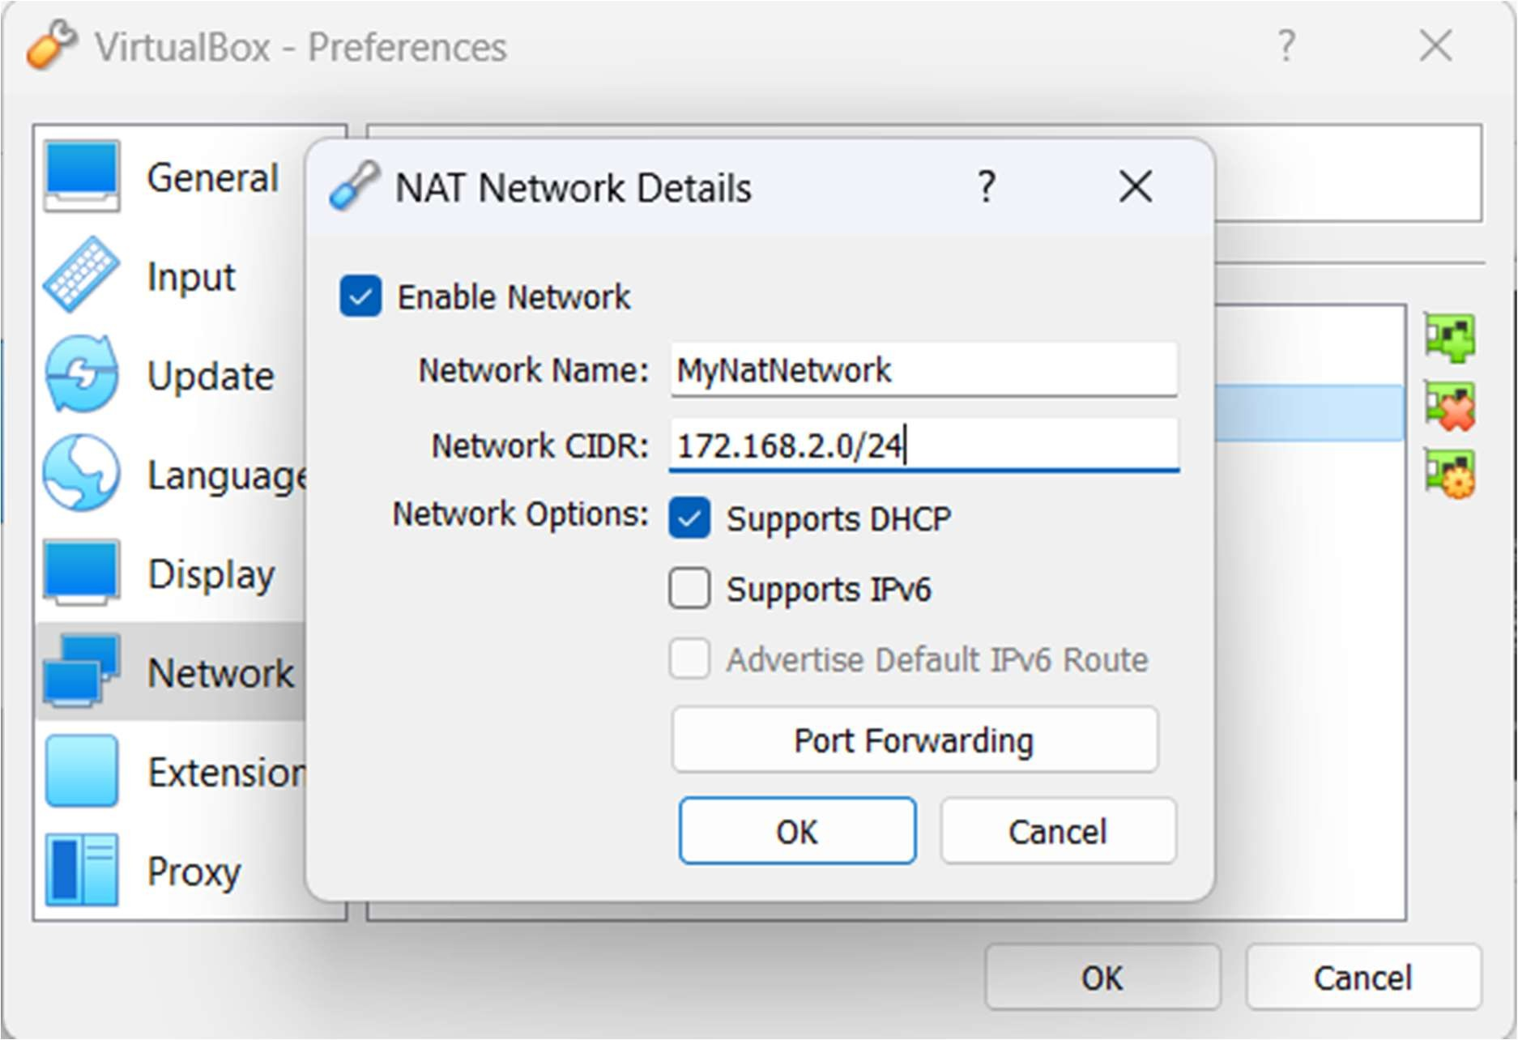

**Step 5**: Connect your VMs to the Nat network

* 1. Right click on VM and go to settings
  2. Go to network and click on Attached to and choose Nat Network
  3. Choose Name of your network created (NatNetwork)

Do this to both the VMs

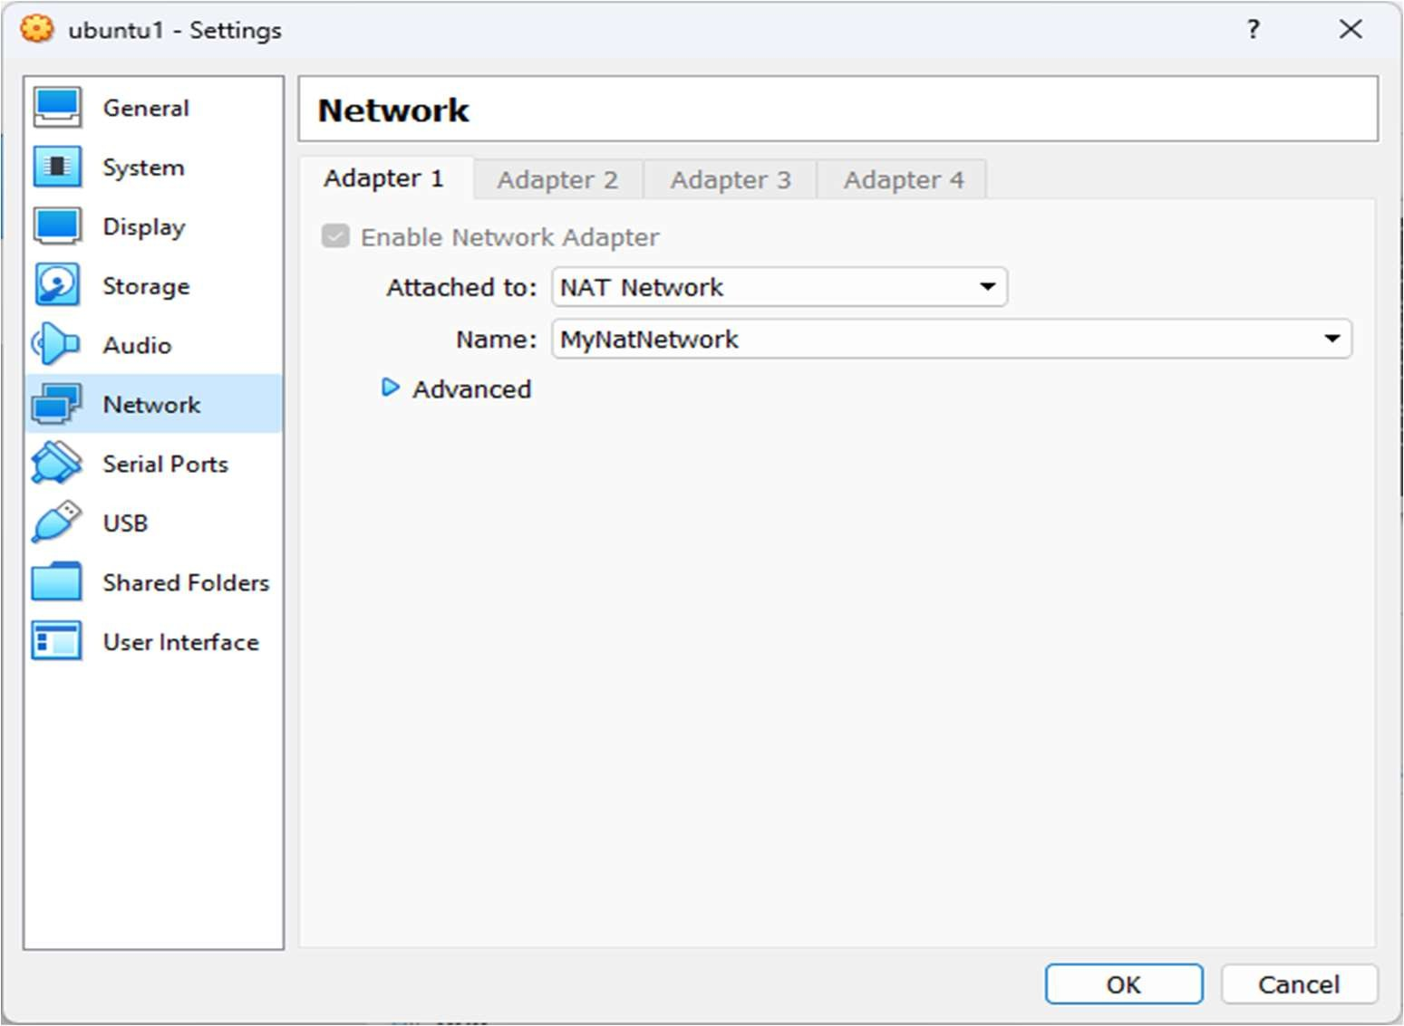

**Step 6: Start Both of your VMs**

Default login: username: vagrant password: vagrant

On machine 1:

To Create new Folder : mkdir (folder-name) To open folder: cd (folder-name)

To Create new File : touch (file-name).txt

**\*note replace (file-name) with your file name and (folder-name) with your folder nam**

Machine 1:

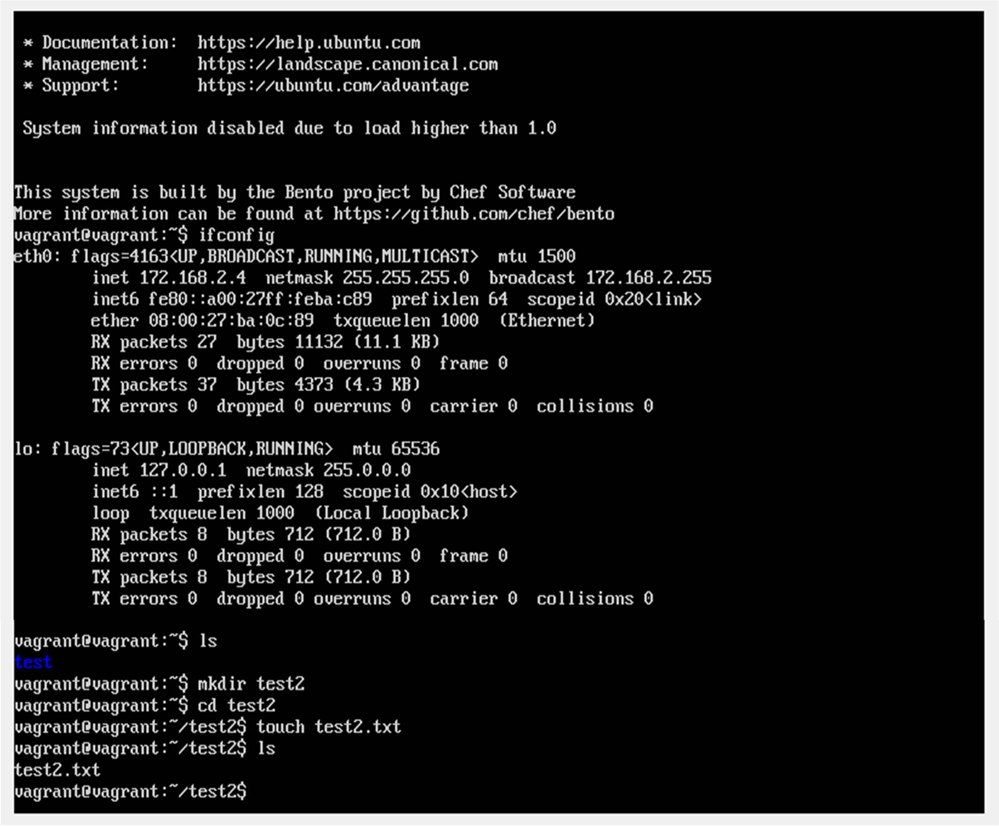

On machine 2:

To get IP of you machine: ifconfig (note down the IP, in this VM is 172.168.2.5 yours might be different)

To Create new Folder: mkdir (folder-name) To open folder: cd (folder-name)

**\*note replace (file-name) with your file name and (folder-name) with your folder name**

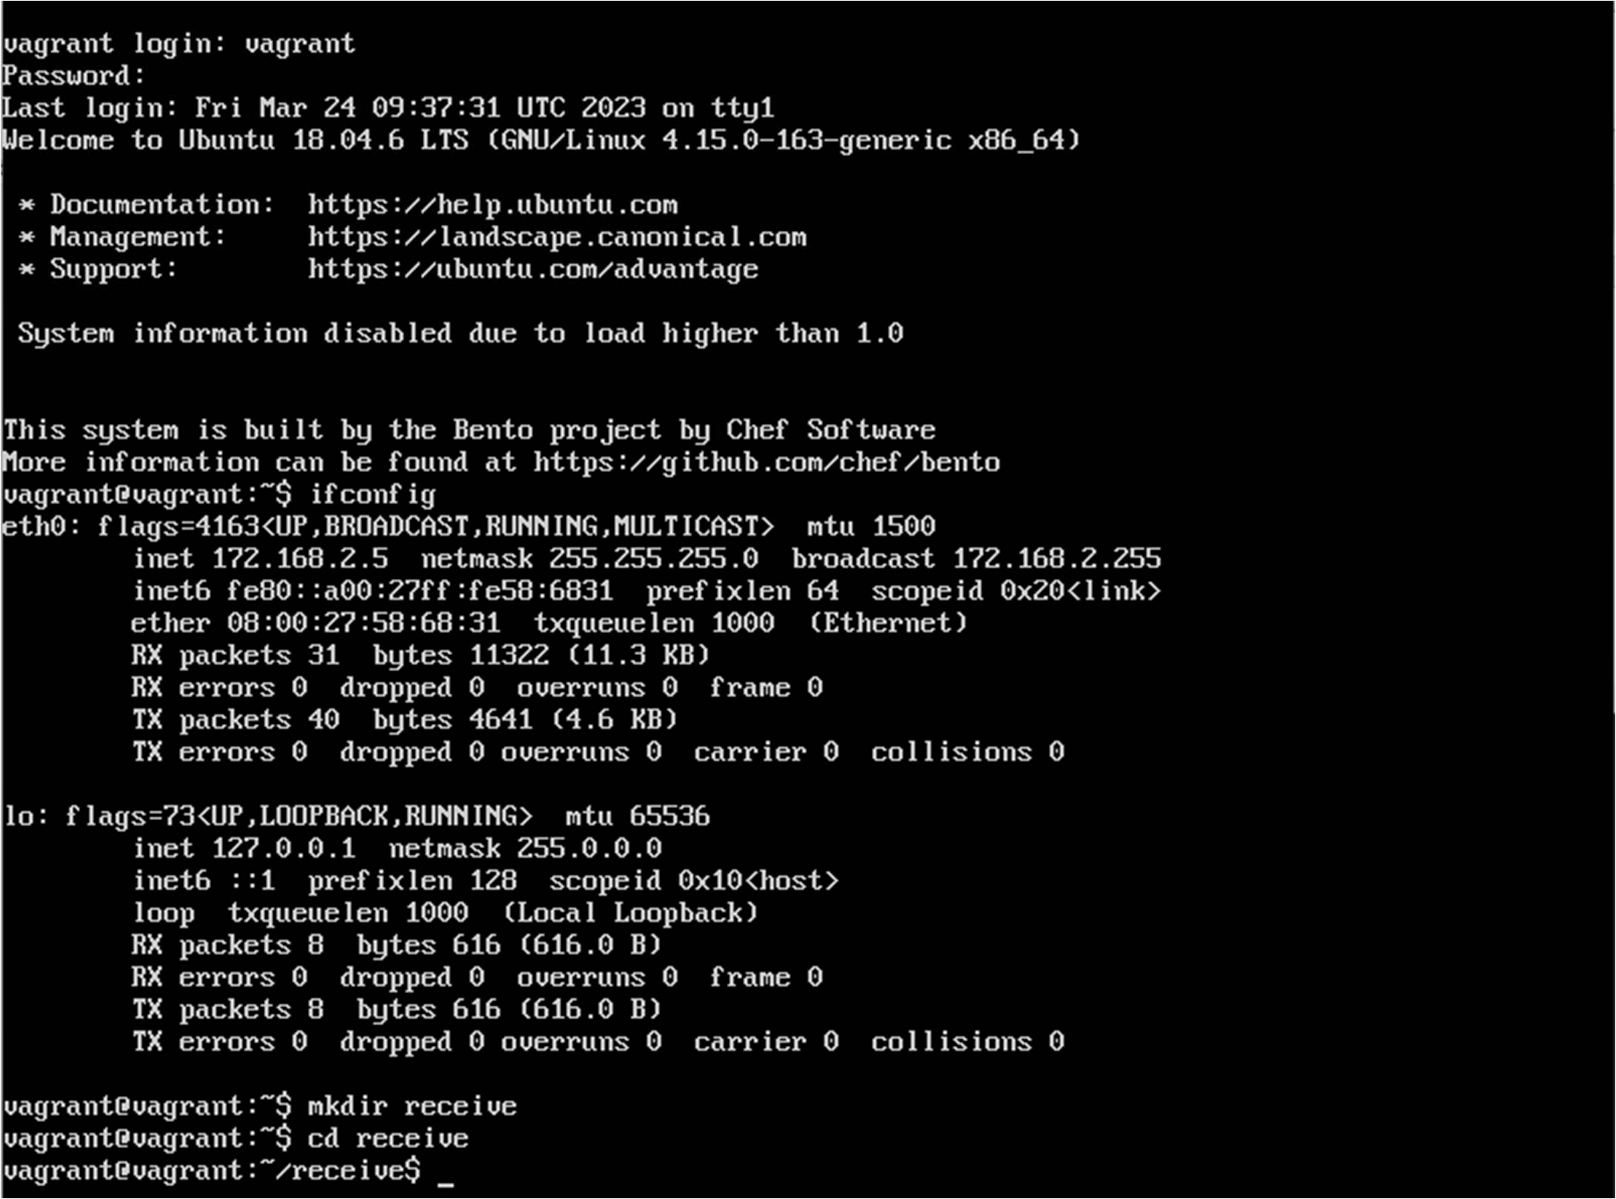

**Step 7: Send a file from machine 1 to machine 2**

On machine 1:

To send file:

scp (file-name).txt vagrant@(IP Address):/home/vagrant/(folder-name created in machine 2)

It will ask for password, by default the password is **vagrant**.

**\*note replace (file-name) with your file name and (IP Address) with IP address of your machine 2**

Machine 1:

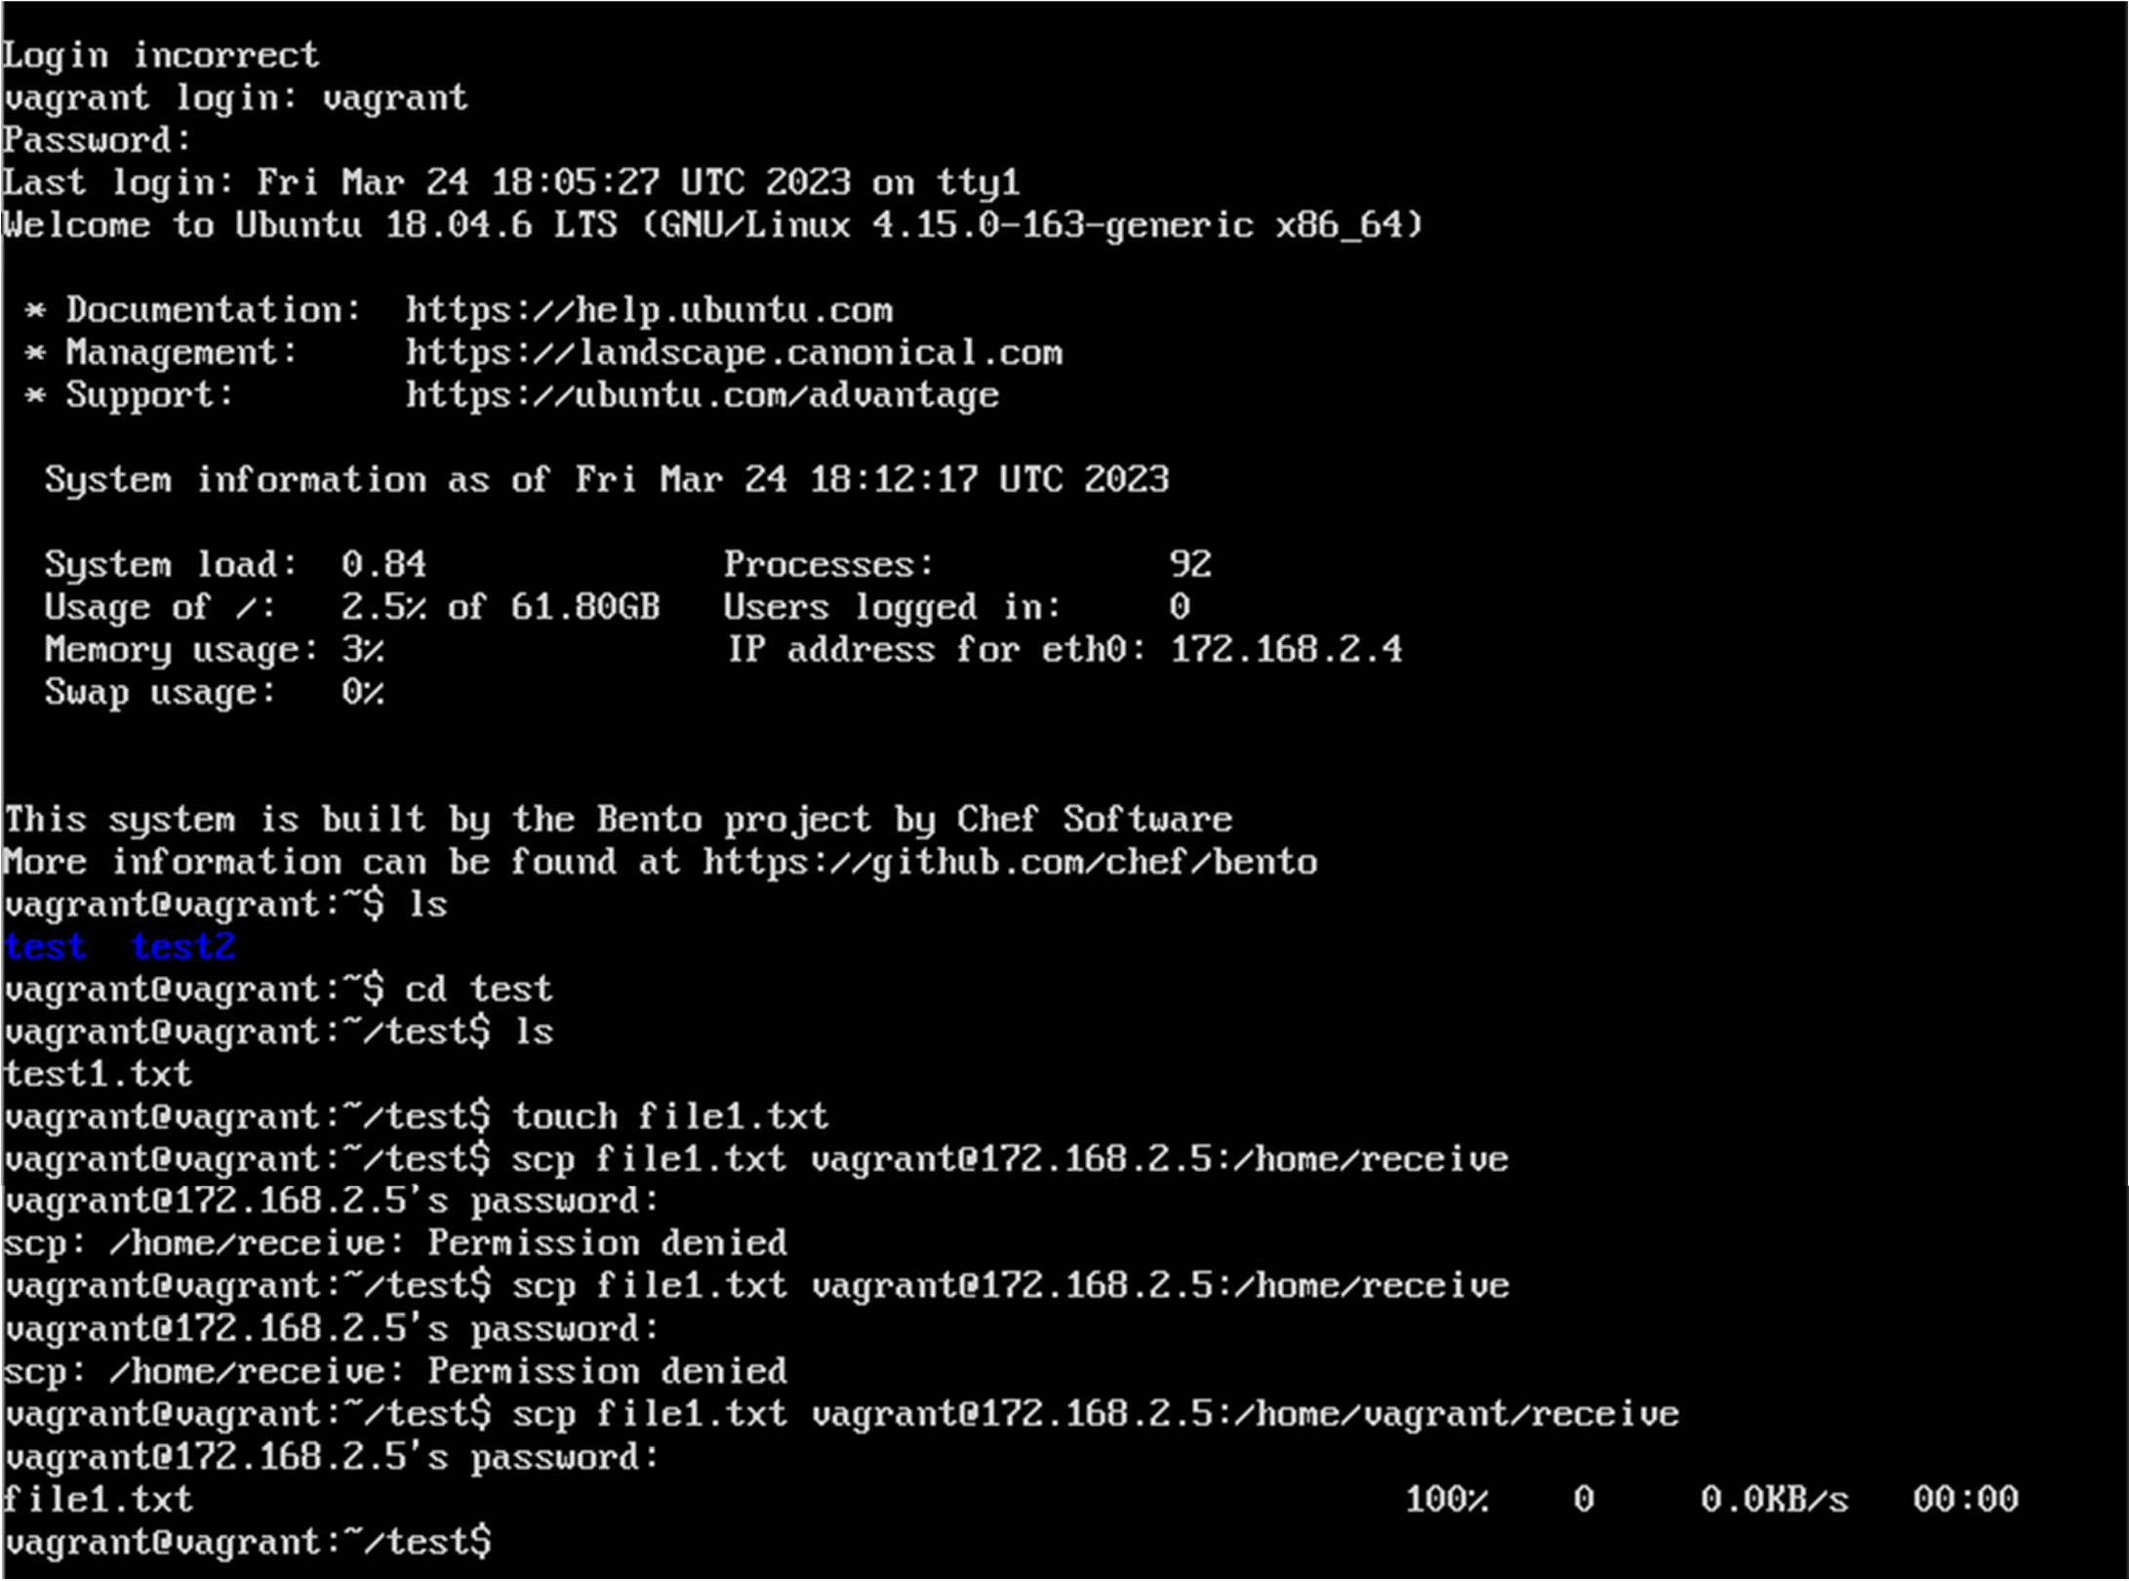

On Machine 2:

To check if you received the file

Go to your created folder and use: ls

Machine 2:

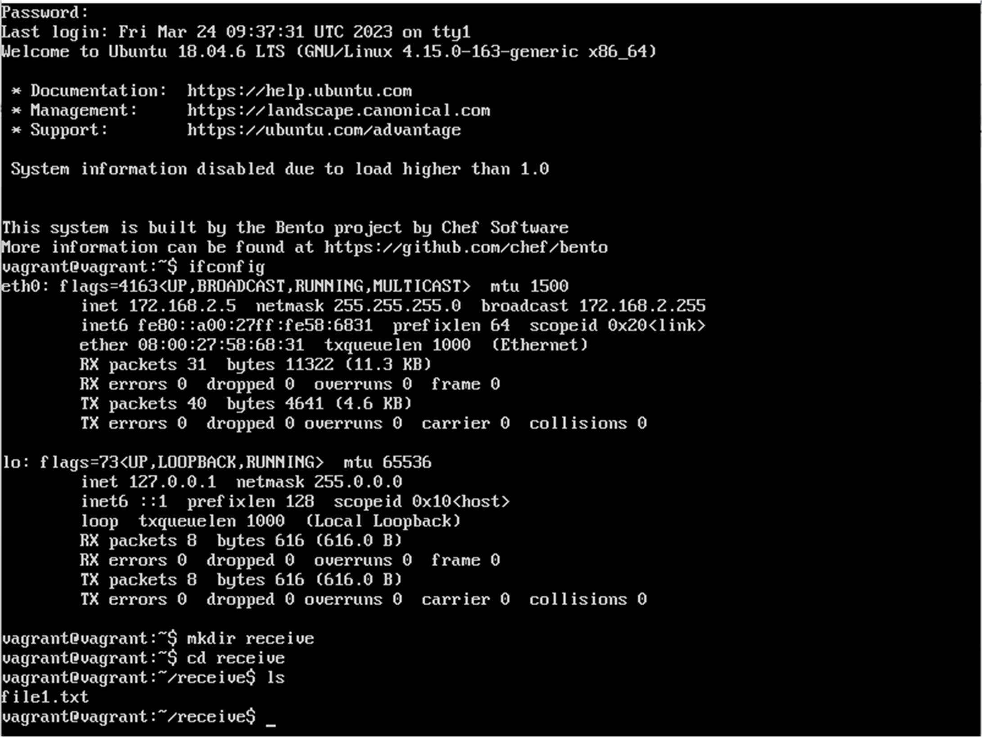

You can repeat step 7 to transfer different files.

To understand the steps or if this steps didn’t work for you, you can refer this video: https://youtu.be/0MaS0nZCTZc

**Result:**

Thus the program to the File transfer operation using virtual machine was successfully executed and verified.

**FAQ:**

1)What is the objective of virtual machine?

2) What are the types of virtual machine?

**Assignment No : 05**

**Aim:** Steps to install openstack on Ubuntu 18.04 in Virtual box

**OpenStack is a cloud operating system that controls large pools of compute, storage, and networking resources throughout a datacenter, all managed and provisioned through APIs with common authentication mechanisms.**

**A dashboard is also available, giving administrators control while empowering their users to provision resources through a web interface.**

**Beyond standard infrastructure-as-a-service functionality, additional components provide orchestration, fault management and service management amongst other services to ensure high availability of user applications.**

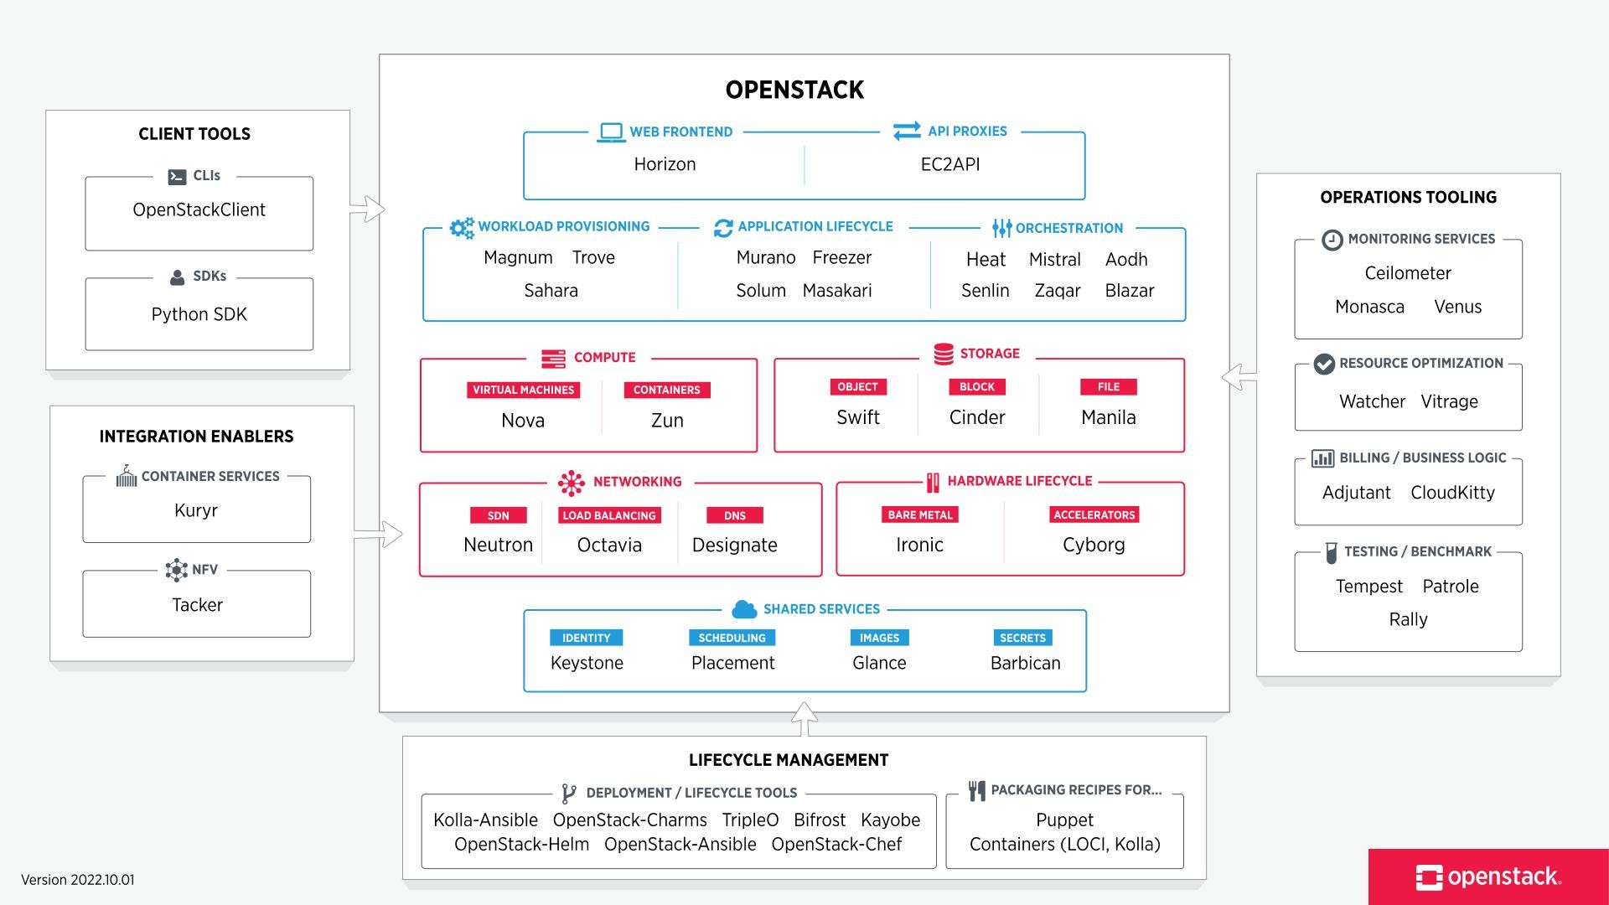

* + **First install virtual box** [**https://www.virtualbox.org/wiki/Downoads**](https://www.virtualbox.org/wiki/Downoads)[**.**](http://www.virtualbox.org/wiki/Downoads)

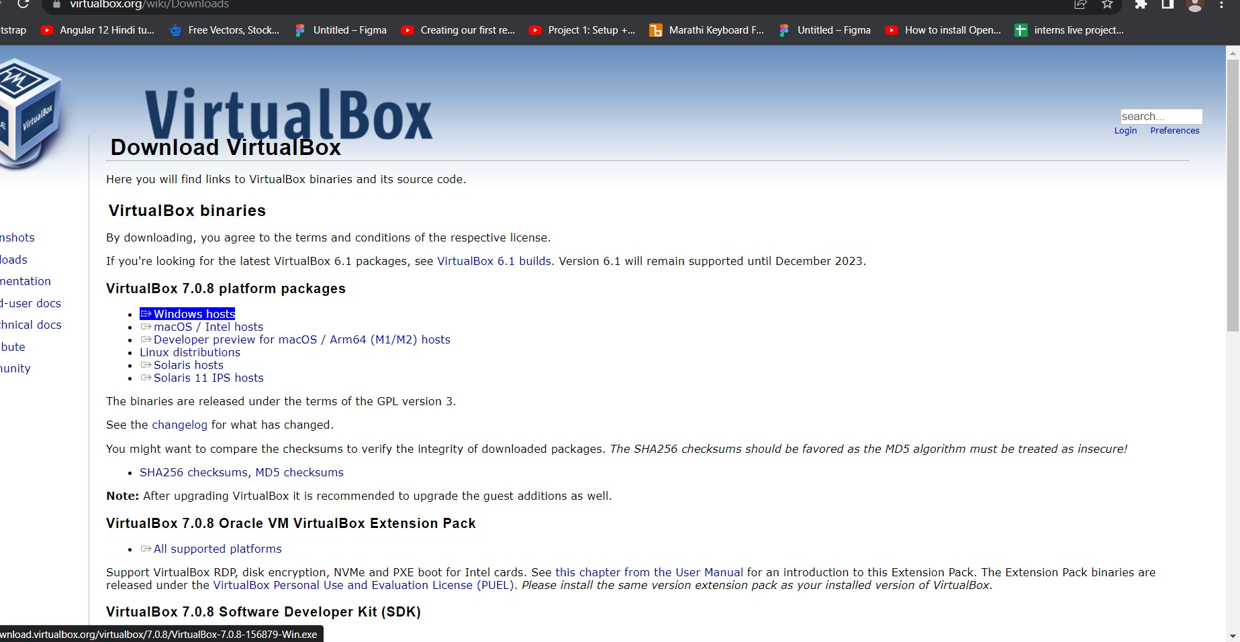

* + **Download Ubuntu 18.04 ISO https://releases.ubuntu.com/18.04**
  + **Now,open Virtual box and Create new Ubuntu 18.04 VM in Virtual box 4 GB RAM +**

2 vCPUs

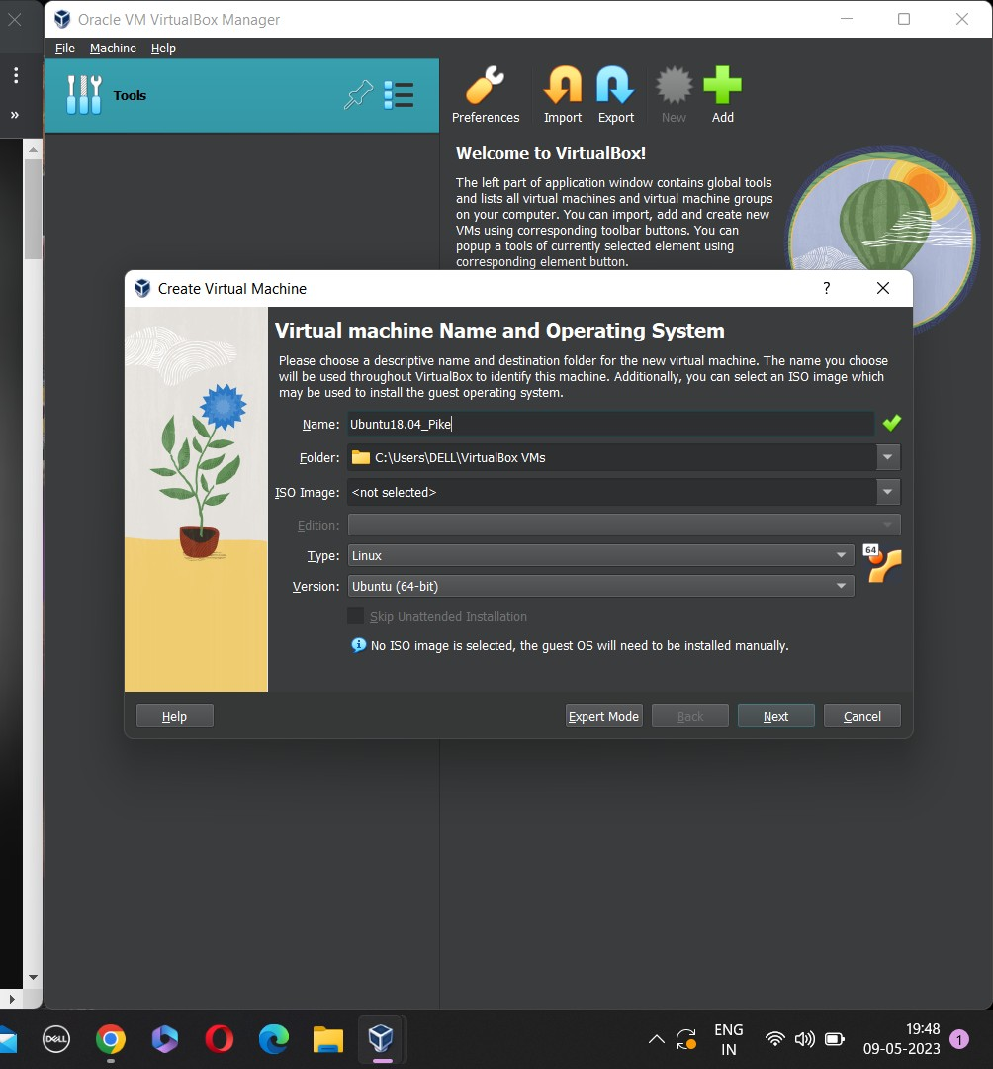Hard disk capacity of Min 10 GB

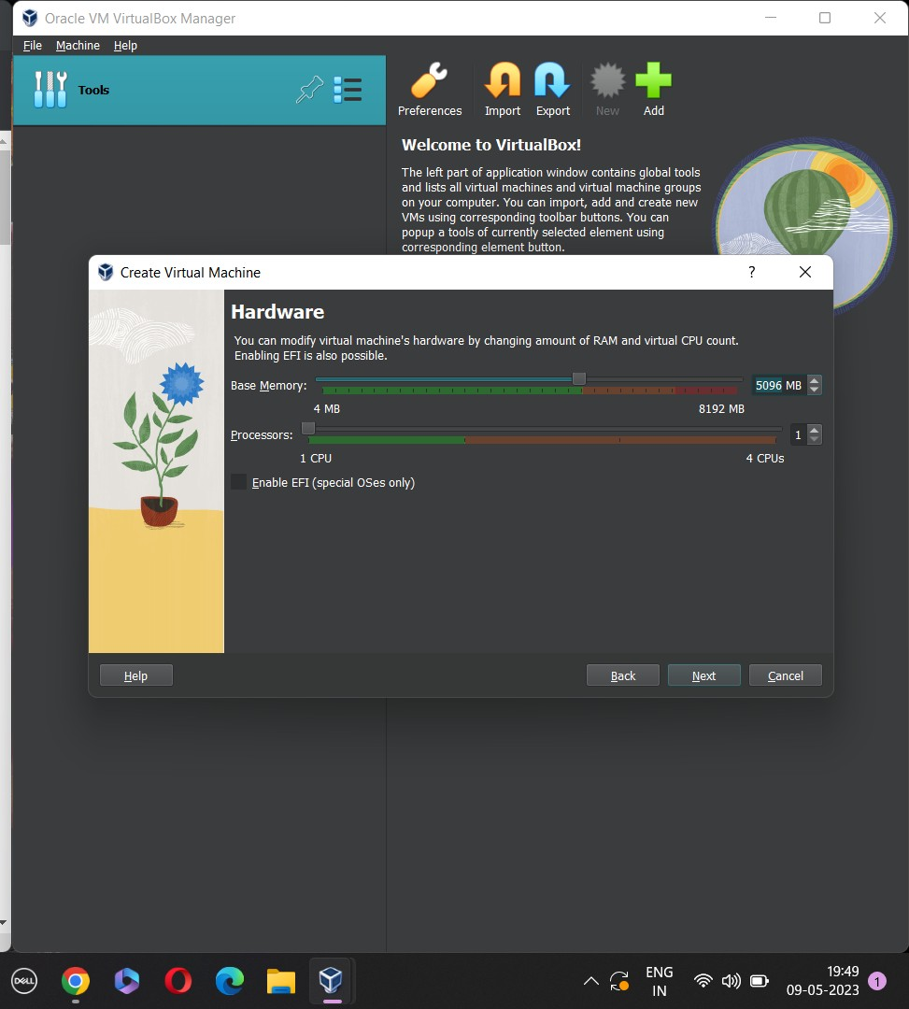

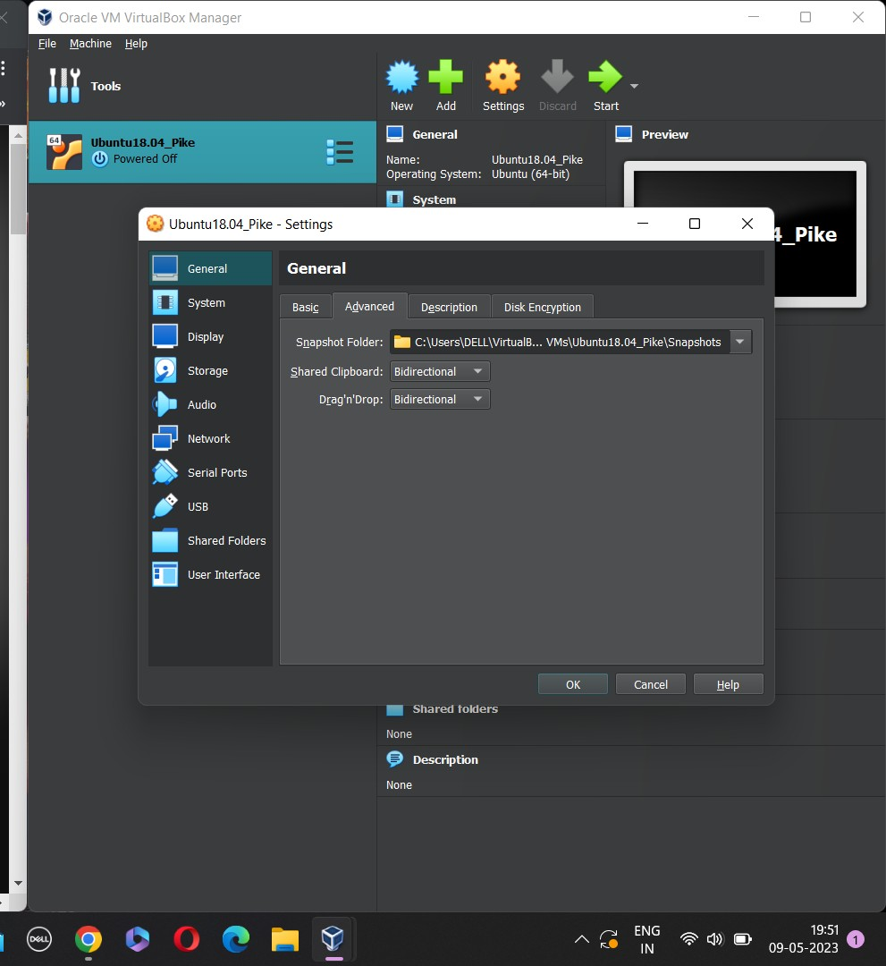 Now change settings of created virtual machine

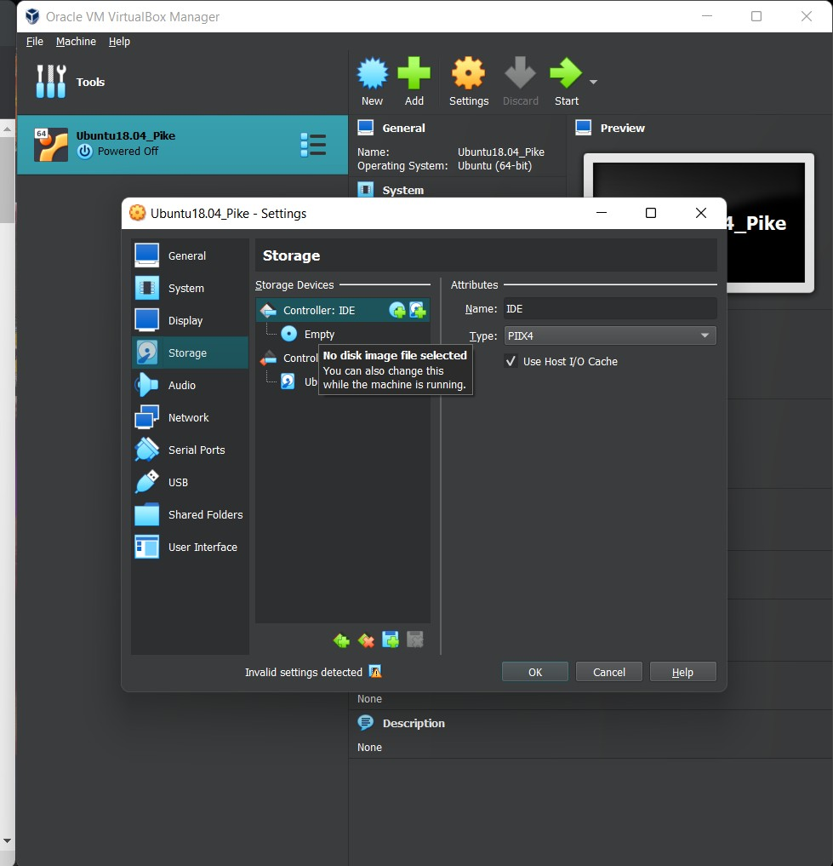

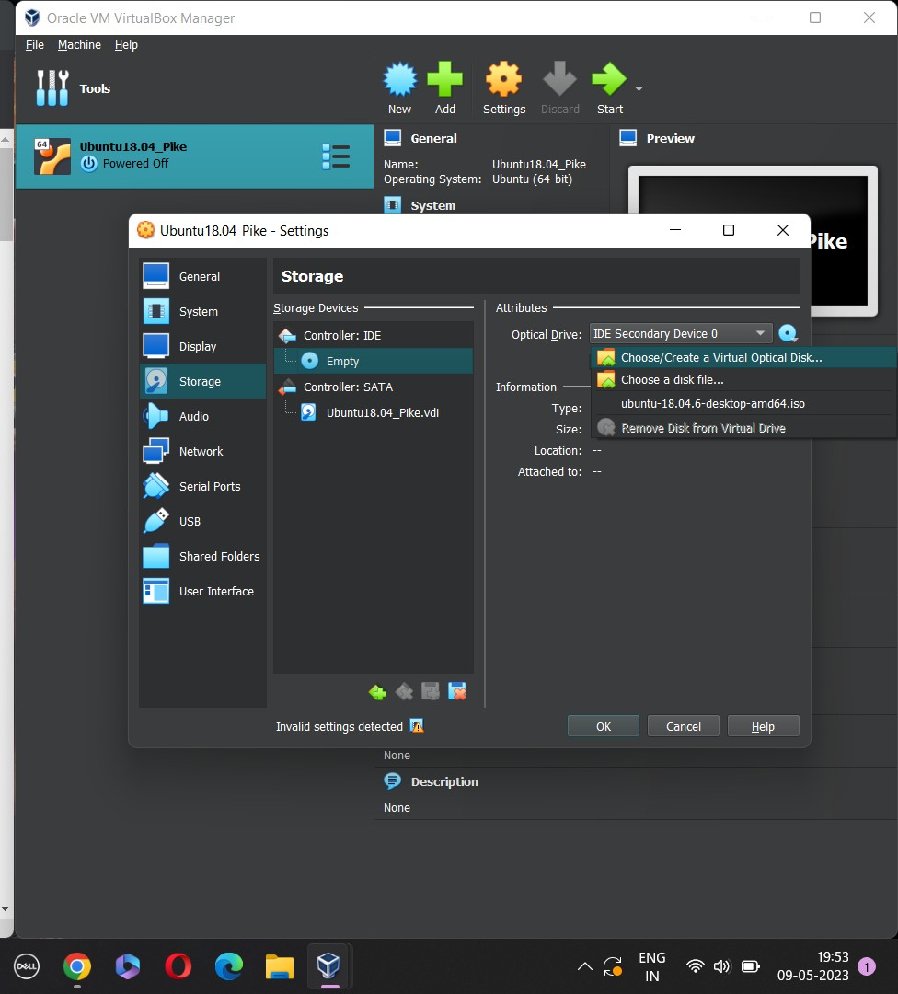

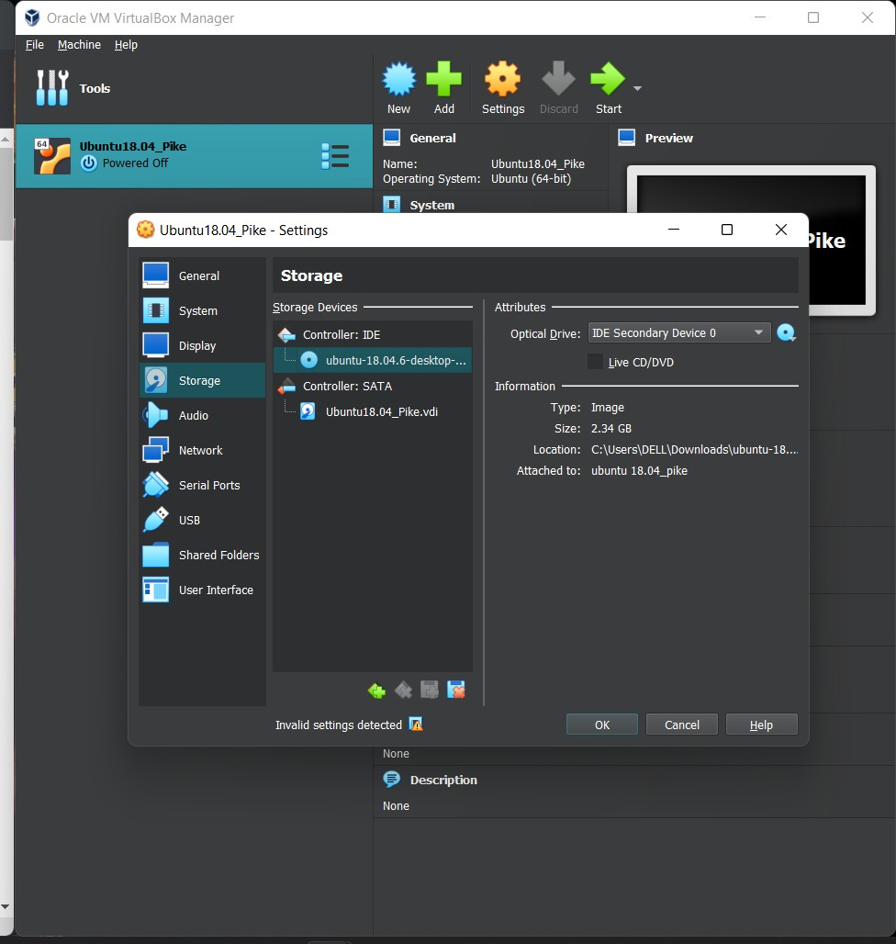

Now open the Created VM and do following settings

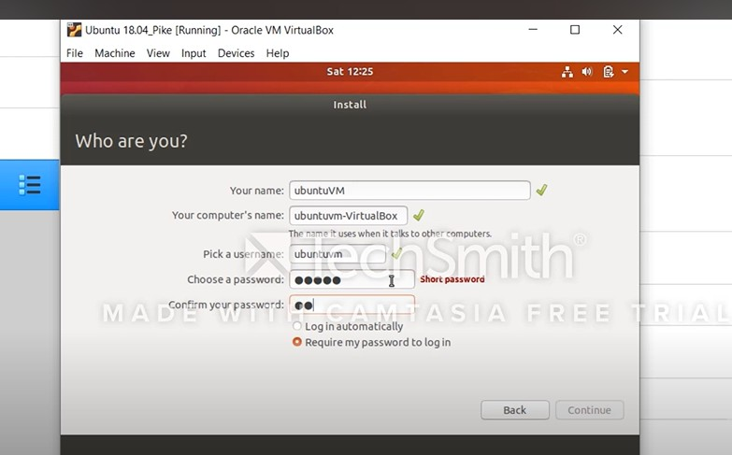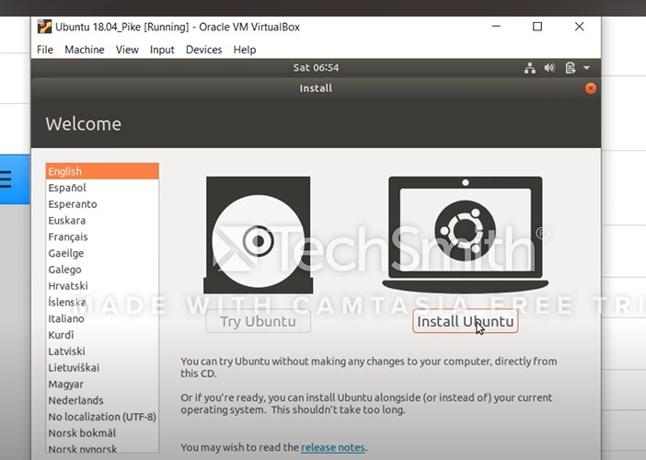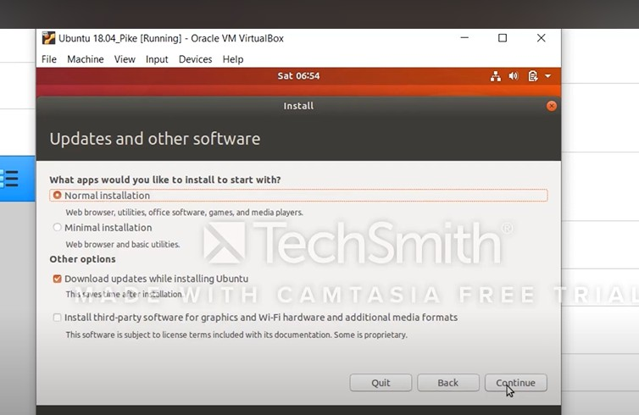

**4) Now ,Open the Terminal inside Ubuntu instance and run following commands Execute below steps in terminal:**

sudo su

apt update -y && apt upgrade -y sudo reboot

sudo useradd -s /bin/bash -d /opt/stack -m stack

echo "stack ALL=(ALL) NOPASSWD: ALL" | sudo tee /etc/sudoers.d/stack sudo su - stack

If git not installed:

=======================

sudo apt install git -y

=======================

git clone https://github.com/openstack-dev/devs... -b stable/pike devstack/ cd devstack/

ifconfig

If it did not work:

==========================

sudo apt install net-tools

==========================

[[local|localrc]] ADMIN_PASSWORD=secret

DATABASE_PASSWORD=\$ADMIN_PASSWORD RABBIT_PASSWORD=\$ADMIN_PASSWORD SERVICE_PASSWORD=\$ADMIN_PASSWORD HOST_IP=10.0.2.15

RECLONE=yes EOF

./stack.sh

If stack.sh failed with permission error:

====================

FORCE=yes ./stack.sh

====================

* + 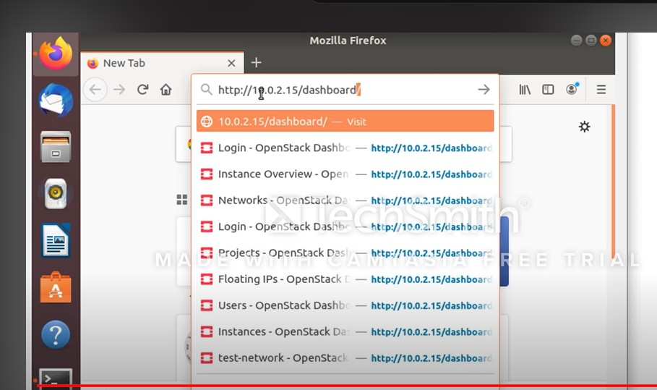**After succesful installation of Openstack access the Horizon dashboard with below URL:** [**http://10.0.2.15/dashboard**](http://10.0.2.15/dashboard)

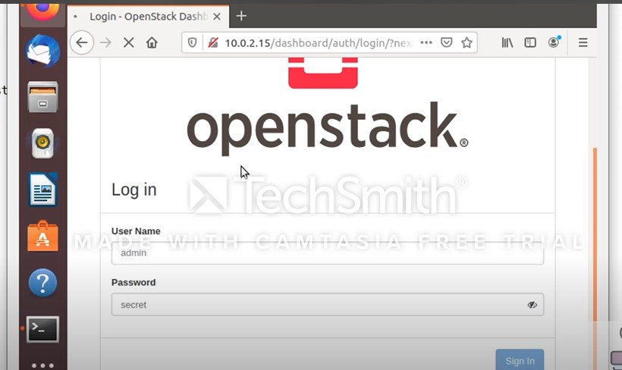

**FAQ:**

1) What are the 7 OpenStack components?

**2) What are the uses of OpenStack?**

**Assignment No. : 06**

**Aim:** Design and deploy a web application in a PaaS environment.

Prerequisite Requirement:

* AWS Account
* Build file of your Angular application or React application

For AWS Account:

Visa or Mastercard Credit/Debit Card is Required. 2 rs will be debited for verification of card.

To create build file of Angular application: Open your application folder in vscode

Go in terminal in type “ng build” to create your build file You can find the build folder in your_application_folder/dist

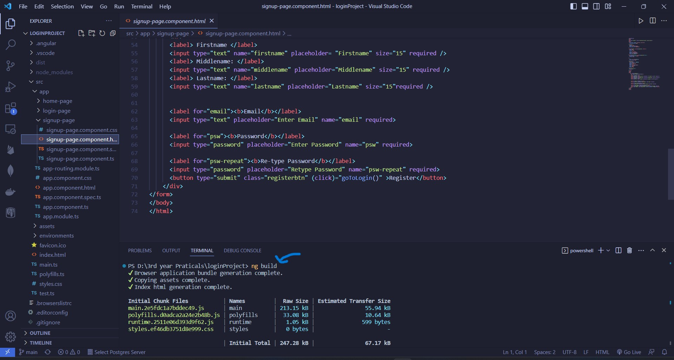

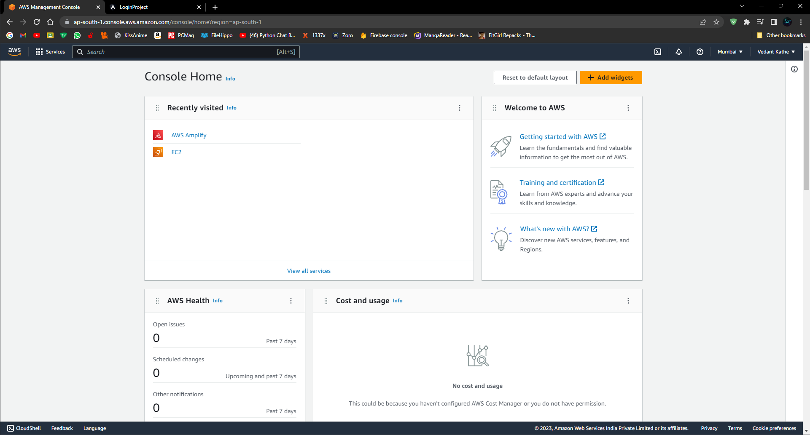

Step 2: Scroll down and find “Host a static web app” option

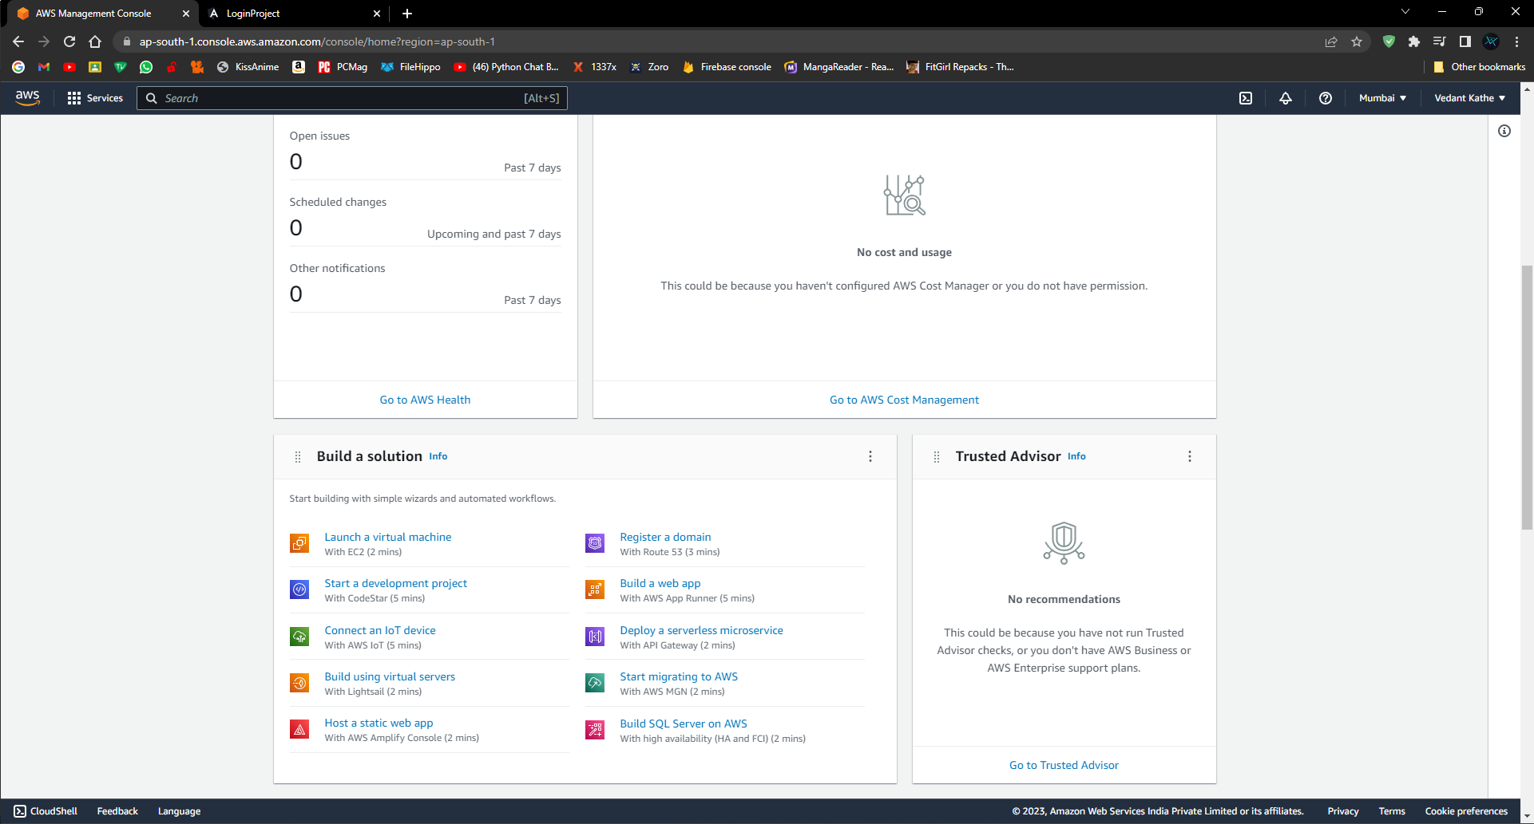

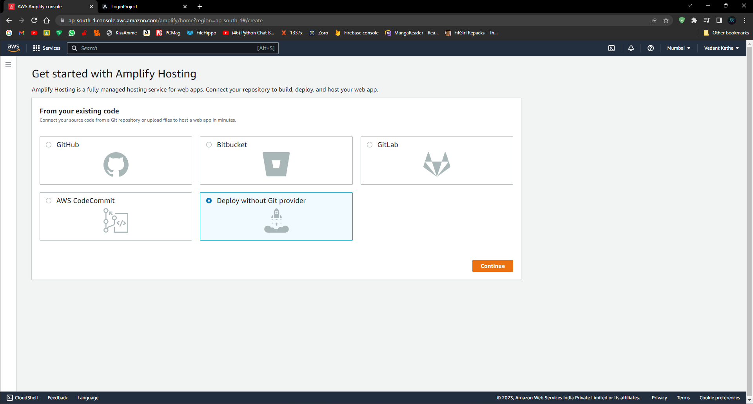

Step 4: Add app name (optional) and then drag and drop your build folder here

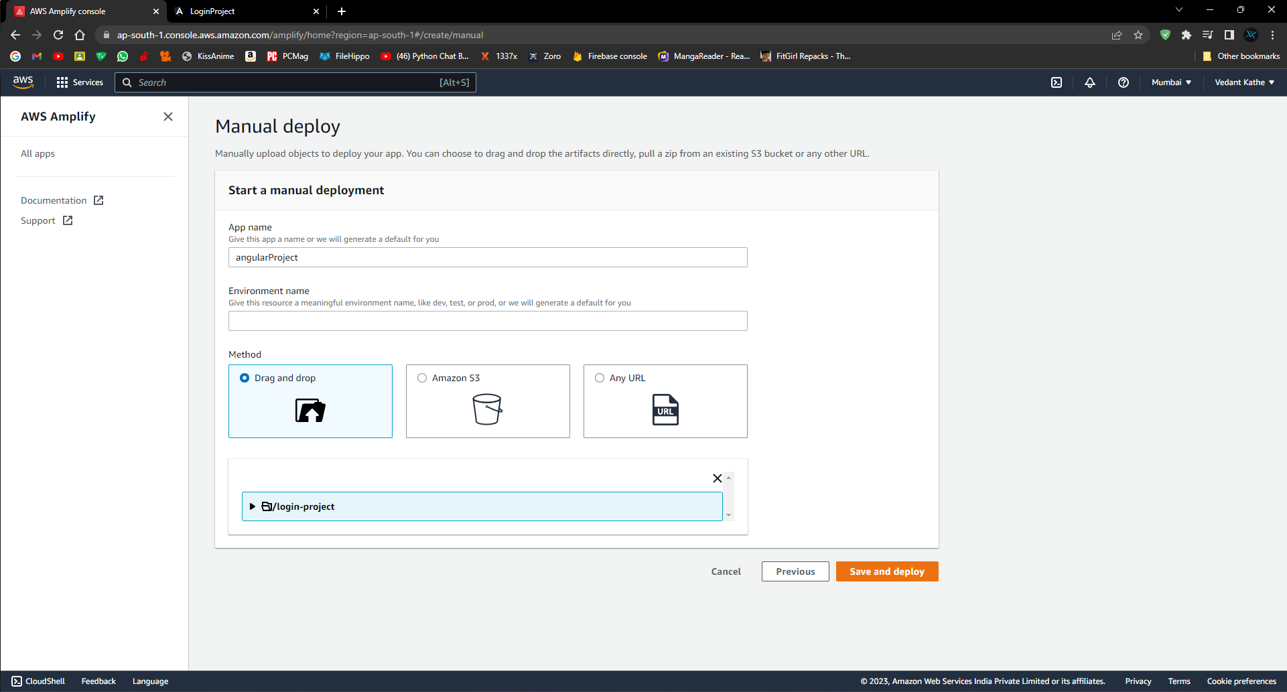

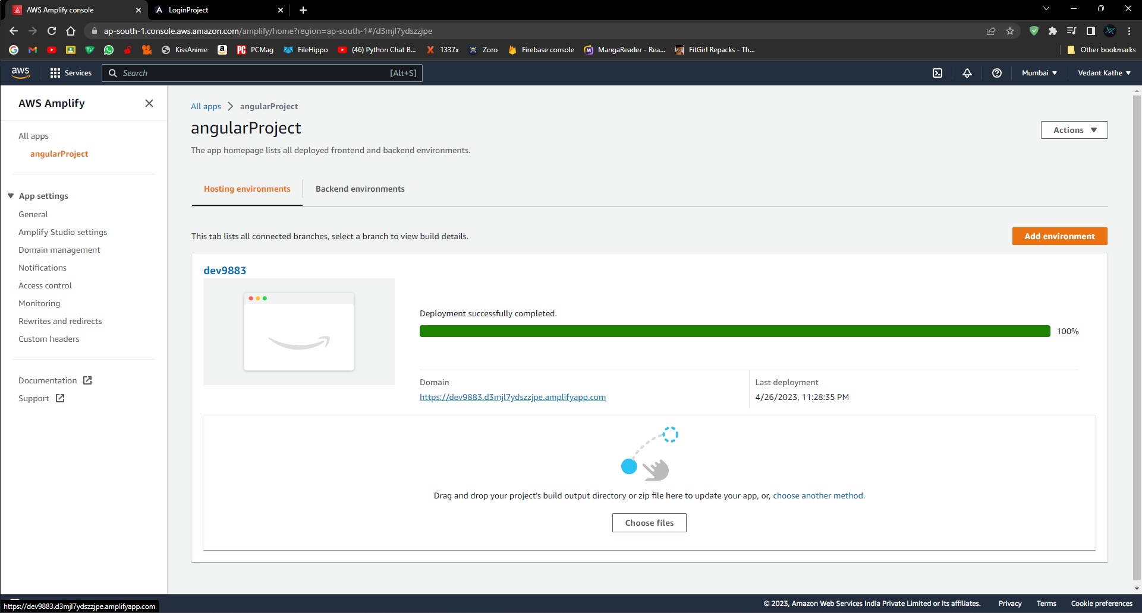

Step 6: Click on the Domain and your Website Will to Displayed

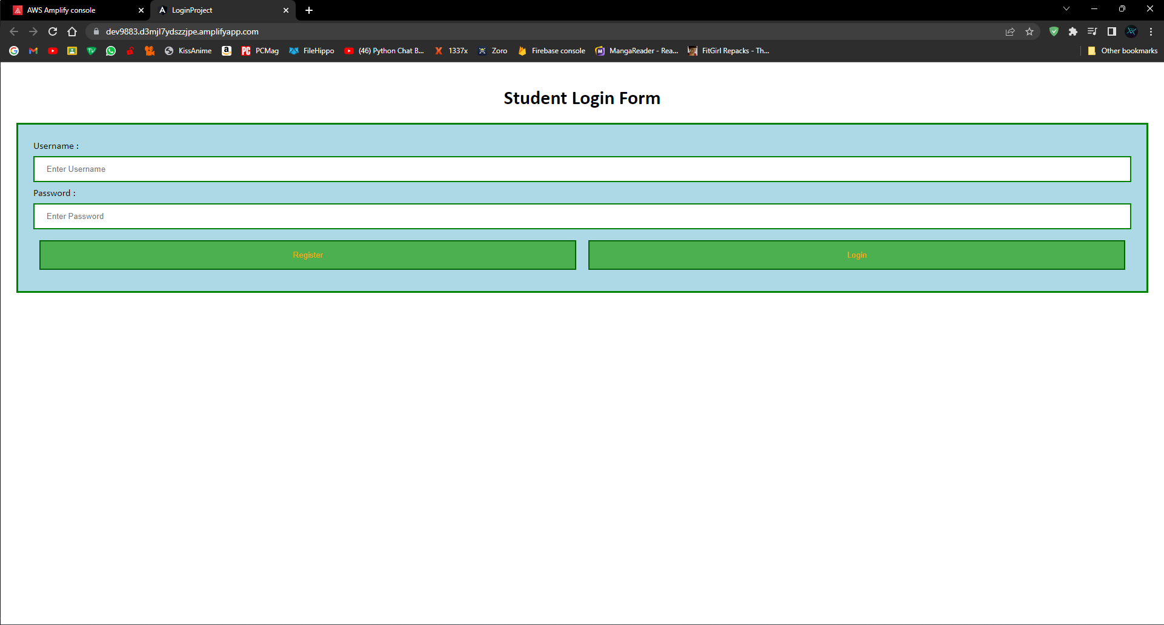

**FAQ:**

1) What is PaaS deployment?

2) How do I create a PaaS application?